Established by the
Treaty of June 9, 1855
Confederated Tribes and Bands
of the Yakama Nation

Advertisement and Notes for Design Proposals for Lynch Lane Stream Restoration
Ahtanum Creek – Yakima, WA

March 10, 2026
Dear Consulting Firms:
The Yakama Nation’s Fisheries Program is seeking design proposals for a stream restoration project located along Ahtanum Creek (RM 18-20) near the Lynch Lane stream crossing in Yakima County, Washington. The restoration designs will aim to address habitat limitations for Mid-Columbia Steelhead. Based upon the proposals received under this solicitation, the Confederated Tribes and Bands of the Yakama Nation will award a contract to the best quality bidder for the Scope of Work. The deadline for submitting your proposal is Wednesday, April 8th – 5:00 PM. Proposals will not be accepted after this date/time.
NOTICE IS HEREBY GIVEN:
Request for Proposal – MUST BE MAILED, EMAILED, OR HAND-DELIVERED TO BE CONSIDERED. Submissions may be received through one of the following ways:
- Please mail a hard copy of your proposal by certified mail, overnight or similar means to:
Yakama Nation Fisheries
C/O Carol Sue Martin
ATTN: Theresa Cripps
PO BOX 151
Toppenish, WA 98948

- Please email electronic bid proposals with the email subject as: Ahtanum at Lynch Lane Stream Restoration Design Proposal – Name of Firm.
Send to the following:
Theresa Cripps, crit@yakamafish-nsn.gov
Tana Hoptowit, hopt@yakamafish-nsn.gov
Email verification will be sent to confirm receipt of proposal submission.
- Please drop off a hard copy of your proposal to Theresa Cripps at the Yakama Nation Fisheries office at:
4690 WA-22, Toppenish, WA 98948 – Office 106.

For technical questions ONLY regarding the RFP: Document the email subject as: Ahtanum at Lynch Lane Stream Restoration Design Proposal Question – Name of Firm.
Send to the following:
  - Rebecca Mitre - mitr@yakamafish-nsn.gov
  - Audrey Scott – scoa@yakamafish-nsn.gov

Please review the attached Consultant Services Agreement template for typical Yakama Nation contracting terms and conditions, including reporting/invoicing requirements.

Site tour on Wednesday March, 18th at 11:00am for interested consultants to learn more about the project site and ask questions. Please RSVP with mitr@yakamafish-nsn.gov by 3/16 at 5pm PST.

Last day to submit questions: Tuesday 3/31

The deadline for submitting your proposal is Tuesday April 8th at 5:00pm PST.

Proposals will not be accepted after this date/time.

Project Background and Scope of Work
Project Background
The Ahtanum Creek watershed is located within Yakima County and the Yakama Nation Reservation. A mid-sized tributary to the Yakima river, Ahtanum Creek is comprised of North and South fork streams, which join to form the main stem. Ahtanum Creek flows through forested areas in the upper reaches, an agriculture dominated mid-reach, and quickly developing, residential and industrial areas in the lower sections of the creek near the confluence with the Yakima River.
In the past, Ahtanum Creek has supported populations of spring chinook (Oncorhynchus tschawytscha), Coho (Oncorhynchus kisutch), bull trout (Salvelinus confluentus), steelhead (Oncorhynchus mykiss), and Pacific lamprey (Entosphenus tridentatus). However, populations have declined over time due to a variety of reasons including, but not limited to, degraded habitat conditions, fish passage barriers, insufficient stream flows, and droughts. In order to address limitations to fish populations, YRWP is seeking design proposals for a portion of Ahtanum Creek located between river miles 18 and 20, near Lynch Lane in Yakima, WA (see Figure 1).
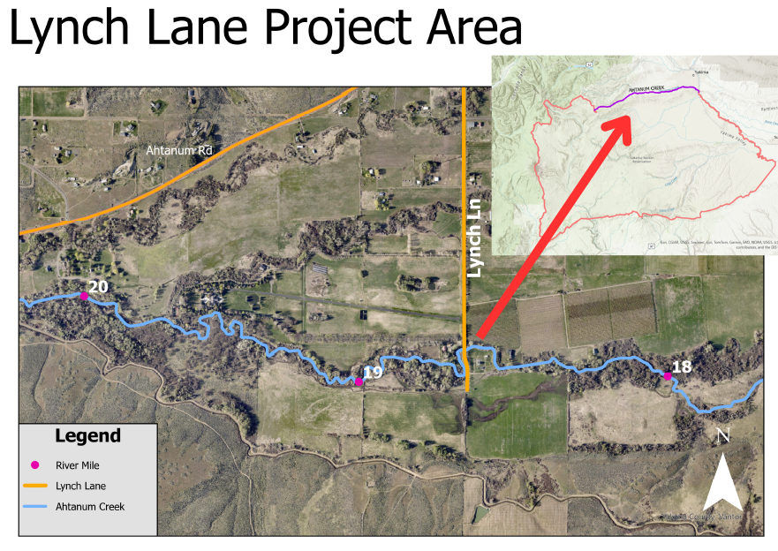
Figure 1. Maps of the project area showing project location in relation to Yakama Nation Reservation.

Design Problem:
At approximately rivermile 19.5 Ahtanum Creek has avulsed from its historic mainstem, and is now flowing along a captured agricultural road alignment and field. Google Earth imagery shows the avulsion occoured in approximately 2013 and has expanded in extent over time (see Figure 2). Flow from Ahtanum Creek’s main channel can be seen diverging in several additional locations between river miles 18 and 20 (see Figure 3).

Engineered designs are required to stabilize the creek and prevent a full channel avulsion in the future. Over time, several incised channels have formed in the adjacent properties south of Ahtanum Creek (see Figure 4). These channels lack a well-defined connection back to creek, leading to concerns over potential salmonid stranding.
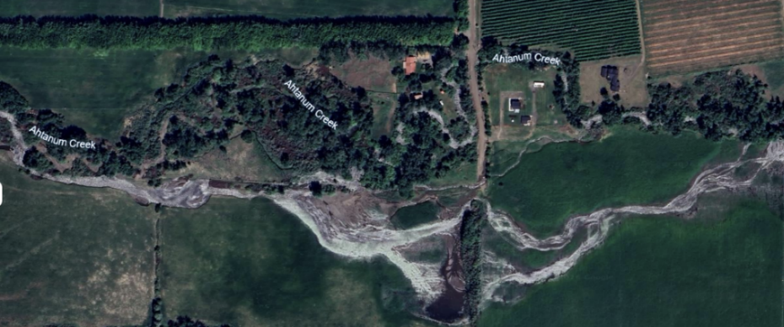
Figure 2. Aerial photo of the growing avulsion in 2023.
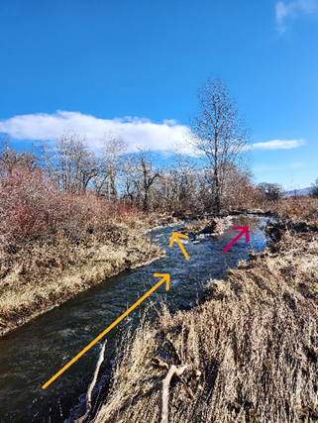
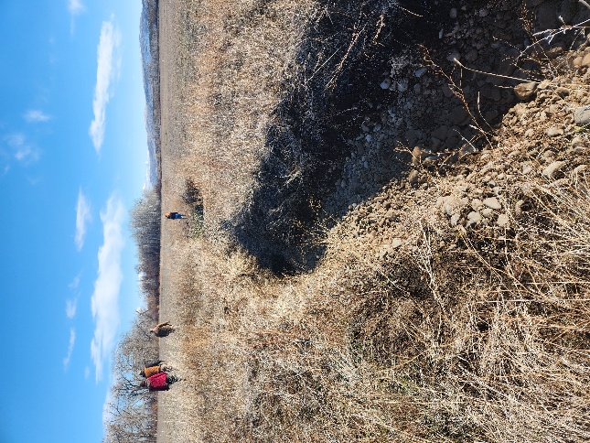

Figure 4. Example of incised channel in nearby field.
Figure 4. Diagram showing the direction of flow in the main channel (yellow) and the redirected flow into the nearby field (pink).

Proposed Scope of Work: Goals and Deliverables
The Ahtanum at Lynch Lane Stream Restoration project aims to improve MCR steelhead habitat quality in addressing the reach’s current issues with avulsion and sediment transport between river miles 18 and 20. This will be done through a project site assessment and hydraulic modeling, which will result in an alternative analysis of conceptual designs. Field data will need to be collected and incorporated into a 2D HEC-RAS model. The successful consultant will provide design alternatives, and a full design planset with analysis that align with project goals, and a Basis of Design Report (BDR). Yakama Nation will collaborate with the successful consultant, partner organizations, and landowners to select an alternative to advance to the construction-ready level design planset.

The goal of improving habitat quality will be achieved through the following project objectives:

- Address the existing channel avulsion and design a more stable stream alignment using stable habitat LWD structures and other restoration treatments for as much of the work as possible.
- Assess fish stranding risk for the newly formed channels near rivermiles 18 – 20.
- Identify fish habitat restoration opportunities along Ahtanum Creek rivermiles 18 – 20.
  - Potential restoration strategies include (but not limited to): Full channel re-alignment, side channel reconnection, riparian planting, and inset floodplains.

Scope of Work
Task 1. Project Initiation
  - Acquisition and Review of Available Data
    - YN provides available data; it is assumed this data consists of previous passage assessment data, stream flow data, historical air photos, hydrology, and previously collected topographic survey data.
    - Create a project file-share for sharing information and data (password protected).
  - Kickoff Meeting
    - Confirm overall project approach and scope of work with respect to objectives, tasks, communication, review periods, and schedule.
    - In person meeting in Toppenish; followed by a visit to the project site.
Task 2. Site Assessment
2.1. Habitat Survey
- Field-based metrics (USFS Level II protocols): habitat units, residual pool depth, active channel width, large wood counts, pebble counts, and riparian conditions.
- Relate habitat conditions to native salmonid and lamprey life-history requirements.
- Results will be summarized in tables and figures with associated narrative interpretations, especially as they apply to the identification of potential stream stabilization activities.
  - Geomorphology Assessment
- A geomorphologist will survey each reach within the study area and characterize bio-physical conditions and channel processes.
- Identify and map anthropogenic features and their impacts.
- Sediment characterization by reach (ocular with gravel counts done periodically for validation): types, distribution, availability.
- Characterize riparian ecological processes (species communities, conditions for vegetation establishment, LW recruitment potential, stability and roughness, human impacts).
  - Topographic Site Survey
- Perform detailed topographic surveys of the stream channel, adjacent floodplain, etc.
- Establish channel cross-sections and longitudinal profiles at intervals sufficient to support model calibration and validation.
- Bathymetric survey of wetted channel bed and topographic survey of channel banks and floodplain.
  - Data Analysis
- Prepare data to be integrated into the hydraulic model (Task 3)
- Produce and existing and proposed terrain model
- Incorporate results into Basis of Design (BOR) report and final designs.
Task 3. Hydraulic Modeling and Analysis
3.1 Comprehensive hydrologic and hydraulic modeling
- 1D HEC-RAS Modeling: Develop a one-dimensional HEC-RAS model to simulate inundation patterns under variable flow conditions. This component is optional if the two-dimensional model sufficiently captures inundation dynamics.
- 2D HEC-RAS Modeling: Construct a two-dimensional HEC-RAS model to assess spatial variations in stream energy across a range of flow scenarios, including but not limited to Bankfull, 50%, 10%, and 1% annual-chance events.
3.2 Hydrologic Data Integration
- Utilize existing flow datasets where available. In areas lacking sufficient data, apply USGS StreamStats or other appropriate regional hydrologic tools to estimate flow parameters.
3.3 Flow Regime Assessment
- Identify and characterize hydrologic impairments and anthropogenic modifications affecting the natural flow regime within the study area.
3.4 Model Validation
      - Calibrate the model using observed flow and stage data, where available. Validate model performance against independent datasets or high-water marks from known events.
      - Conduct sensitivity testing on key model parameters (e.g., Manning’s n, boundary conditions) to evaluate model robustness and identify potential sources of uncertainty.
      - Provide a technical memorandum summarizing model setup, calibration/validation results, assumptions, limitations, and recommendations for future refinement.

Task 4. Conceptual Designs and Alternatives Analysis
4.1. Concept and Alternative Drawings
- Work with YN staff to develop design criteria.
- Organize and lead a workshop with YN and project partners to identify up to three alternative designs.
- Develop up to three alternatives to a 15% level and provide planview drawings for each alternative.
- Designs should integrate information from Tasks 1-3.
- If needed, the consultant will provide example photos and designs from previous projects.
- YN will facilitate all stakeholder engagement.
- Conceptual designs may include illustrations and other media to assist with design comprehension; however, they will also include a set of CAD drawings that depict the above specifications.
4.2. Cost/Benefit Analysis
- Evaluate each alternative based on physical, biological, and engineering feasibility.
4.3. Design Alternative Technical Memo
- Brief description of the design alternatives and cost/benefit analysis.
- Summary of hydrologic analyses and selection of design flows.
- Summary of hydraulic model development.
- Summary of existing and proposed hydraulic conditions for each alternative.
- Discussion of how project objectives are met through the design.
- Meeting with YN to workshop alternatives based on documents provided in 4.1-4.2.
- YN will choose a preferred alternative and approve advancement to preliminary designs.
Task 5. Preliminary Design Reports and CAD Drawings
5.1. Design Survey
- Gather additional topographic data points necessary to further advance designs and modeling for the preferred alternative.
5.2. Preliminary Design Planset
- Review and address YN comments on conceptual designs.
- Advance designs to draft design drawings for the extent of the project area.
5.3. Preliminary Basis of Design Report
- Produce a draft BDR to include field survey results, description of restoration treatments, applicable design calculations, and hydraulic modeling results.
5.4. Preliminary Design Workshop Meeting
- Meet with YN to present design updates and answer technical questions.
- Implement feedback from the meeting into the next iteration of designs.
Task 6. Final Design Reports and CAD Drawings
6.1. Final Draft Design (80%)
- Incorporate comments from YN and move the draft design plants to a first draft of the final designs.
- Develop construction specifications.
6.2. Final Draft Basis of Design Report (80%)
- Revised BDR as needed to align with design development.
6.3. Final Design for Construction
- Complete detailed revisions as necessary to move plans to final, construction-ready designs.
- Stamped design drawings.
- Stamped technical specifications.
6.4. Final Basis of Design Report
- Completed and stamped final BDR, technical reports, and calculation packages to accompany construction-ready designs.
Task 7. Project Management
7.1. Project Management and Coordination
- Coordinating design, modeling, and survey efforts.
- Invoicing with explanation of date of service, hours, cost, work performed, and additional notes, as needed.
- Meetings as necessary to meet deliverables in Tasks 1-6 and documentation via meeting notes.
Summary of Task Deliverables
      - Establish a password protected file-sharing system.
      - Kickoff meeting and meeting minutes.
      - Site survey
      - Alternative Designs Technical Memo
      - Conceptual design workshop
      - Conceptual Design package: includes Planset, BDR, and electronic files.
      - Preliminary Design package: includes Planset, BDR, and electronic files.
      - Preliminary Designs workshop
      - Draft Final and Final Design Package, including Planset, Specifications, BDR, and electronic files.
      - Construction-Ready Design package, including Planset, Specifications, BDR, and electronic files.
      - Invoices.
      - Meeting notes.

Assumptions & Provisions:
- All final plans and designs will be stamped by a Professional Engineer, licensed in the state of Washington.
- All LWD and other restoration structures will be designed to withstand a 100yr return interval flood. The preferred method of stabilizing LWD structures will be with vibratory driven piles and mechanical fastening. Other methods will be considered.
- YN will arrange for site access and site approval
- YN will provide relevant data to the consultant on request within a reasonable time frame, assuming it is readily available.
- YN will provide reviews and comments in a reasonably timely fashion in response to drafts of deliverables submitted by the consultant.
- YN will designate a project lead who will maintain close communication and coordination with the consultant for this work.
- The Consultant will assess performance under both low-flow and high-flow (100-year) events at all stages of design. This will allow for evaluation of specific hydraulic criteria to ensure project features are passable at low-flows and stable during high flow events.
- Yakama Nation will obtain necessary permits and approvals for all project activity.
- In-water construction fish window is July 15th through October 31st.
- A Yakama Nation Business License is required to enter into a contract with Yakama Nation. Please contact the Yakama Nation Revenue office at (509) 865-5121 ext. 4650 or revenue@yakama.com for application instructions. This is the contractor’s responsibility; we recommend contacting the Revenue Office several months ahead of time.
- Design plans must conform to funding source programmatic and design requirements.
- Subcontracting must be approved prior to contract execution and be clearly described in the proposed scope of work and budget.
- We have attached the Yakama Nation consultant contract template for reference (see Sample Contract section). Contract terms can be altered by negotiation with the Yakama Nation; However, changes to the template can prolong the contracting process considerably and it is preferred to use the template as is. There may be minor changes to this contract between now and final contracting, however it will remain substantively unchanged.
- Please note that various Federal laws and statutes are incorporated by reference into the contract template: it is the contractor’s responsibility to exercise due diligence regarding these provisions.

Proposal Evaluation and Selection Process

Minimum Qualifications for a Responsive Proposal
- Contractors will RSVP for the site visit by emailing mitr@yakamafish-nsn.gov no later than 5:00 PM on Monday March 16th. The tour will begin at 11:00 AM at the site. Directions to the site will be provided with the RSVP.
- Any technical questions in regard to this request for proposals must be emailed to Rebecca Mitre at mitr@yakama-fish.nsn.gov by Tuesday March 31st. Upon receipt of an inquiry an email containing the original question and associated response from YN will be sent out to each contractor.
- Each proposal must be received by the Yakama Nation by 5:00 PM on April 8th. Please send electronic copies to Theresa Cripps at crit@yakamafish-nsn.gov. This will remain a sealed-bid process, meaning that the project lead will not view proposals sent by contractors until the closing date. Theresa will send a confirmation receipt to the contractor to verify official bid submission.
Proposals shall include:
- Proposal submittal content.
- Project approach.
- Relevant past projects and references.
  - Provide three (3) recent references who can be contracted concerning your firm’s RFP. In listing the references, include the name of the client, telephone number, e-mail address, contact person, and the specific work your firm did for the client. The Yakama Nation reserves the right to contact references other than those submitted by the respondent.
- Personnel roster with a statement of qualifications and resumes.
- A completed budget table (see Budget Table and Payment Terms sections for more details) including:
  - Billing rate schedule by position classification and estimated hours per task.
  - Vehicle, lodging, and other travel expenses.
  - Charges for equipment, printing, or other costs.
  - Direct expenses (if applicable)
  - A cost proposal certified by signature as being valid for 180 days is required.
- Proposed timeline and schedule.
Evaluation and Selection Process
Bids will be evaluated and scored by YN staff on the following basis:
- Quality, clarity, and completeness of proposal.
- Cost and value. Preference will be given to lower costs and higher value per cost, all other factors being equal.
- Timeline, with a preference for quicker delivery of the final report.
- Experience designing similar and relevant projects.
- Adequacy and quality of staff and methods proposed.
- References.
- Please note that Tribally owned firms are preferred.
Limitations
The Yakama Nation reserves the right to accept or reject any and all of the proposals received as a result of this request, or to cancel in part or entirely this request if it is in the best interest of the Yakama Nation to do so. This request does not commit the Yakama Nation to pay any costs incurred in the preparation of a proposal.
Consultant’s Obligation
The consultant shall furnish all supervision, labor, equipment, and tools necessary to complete the project as outlined in the proposed Scope of Work.
Budget Table
A completed budget table should be included within the proposal to ensure that cost-value analysis during the YN bid evaluations process is consistent amongst all proposals.
Task | Budget | Timeline
1. Project Initiation
  - Acquisition and Review of Available Data
  - Kickoff Meeting
2. Site Assessment
2.1. Habitat Survey
2.2. Geomorphology Assessment
2.3 Topographic Site Survey
2.4 Data Analysis
3. Hydraulic Modeling and Analysis
3.1. Comprehensive hydrologic and hydraulic modeling
3.2. Hydrologic data integration
3.3 Flow Regime Assessment
3.4 Model Validation
4. Conceptual Design and Alternative Analysis
4.1. Concept and Alternative Drawings
4.2. Cost/Benefit Analysis
4.3. Design Alternatives Technical Memo
5. Preliminary Designs and CAD
5.1. Design Survey
5.2. Preliminary Design Planset
5.3. Preliminary Basis of Design Report
5.4. Preliminary Design Workshop Meeting
6. Final Design Reports and CAD
6.1. Final Draft Designs (80%)
6.2. Final Draft BDR (80%)
6.3. Construction Ready Design - FINAL
6.4. Final BDR
7. Project Management
7.1. Project Coordination and Management
Total

CONSULTANT SERVICES AGREEMENT EXAMPLE

This consultant services agreement is between the CONFEDERATED TRIBES AND BANDS OF THE YAKAMA NATION, a sovereign native nation with its governmental headquarters located at P.O. Box 151 / 401 Fort Road, Toppenish, WA 98948 on the Yakama Reservation (“Yakama Nation”), and [CONSULTANT’S NAME], Tax ID Number _______________, with its primary place of business located at [address] (“Consultant”).
The Yakama Nation wants to obtain technical assistance to accomplish the project, task, study, or other work described in Exhibit A (Scope of Work) to this agreement.
Consultant states that it has the necessary technical expertise, skill, and capability to complete this work for the Yakama Nation.
The parties therefore agree as follows:

STATEMENT OF SERVICES

Work & Standard of Performance. Consultant shall perform the work described in Exhibit A (Scope of Work) to this agreement (the “Work”). Consultant shall, at its sole expense, provide all labor, services, and equipment necessary to complete the Work timely and to the Yakama Nation’s satisfaction, except as expressly provided otherwise in this agreement. Consultant’s performance shall comply with applicable tribal, federal, state, and local law and policy, and be consistent with generally accepted professional best practices, both of which Consultant states it has knowledge of.

Term. This agreement will be effective on the date when both parties have signed it, and will terminate as set forth below, unless terminated earlier in accordance with Article 9 of this agreement (if neither option is selected, Option B shall be the default):

Option A: On March 31, 2027

Option B: Upon Consultant’s satisfactory performance of the Work.

Prior Performance. If the Consultant has performed any Work prior to the effective date of this agreement, then this agreement will govern such prior performance. Except that the Consultant’s invoicing obligations, and the Yakama Nation’s associated payment obligations, as set forth in Exhibit C (Payment Terms), will not arise until after the effective date of this agreement.

Key Personnel. If any of Consultant’s employees or agents are specifically identified in Exhibit A (Scope of Work) as the employee(s) or agent(s) expected to perform the Work, they will be considered Consultant’s “Key Personnel” for purposes of this agreement. Consultant shall ensure that Key Personnel continue to be assigned to the Work until its completion, unless Consultant obtains the Yakama Nation Project Manager’s written consent to a staff substitution.

COMPENSATION

Maximum Compensation. The maximum total compensation approved by the Yakama Nation and payable to Consultant for Work under this agreement is $________________. The Yakama Nation shall not pay Consultant more than this maximum amount for the Work. Consultant acknowledges that this maximum amount (a) is sufficient to perform the Work consistent with the terms and conditions of this agreement and (b) includes all eligible expenses associated with Consultant’s performance of the Work.

Payment. The Yakama Nation shall pay Consultant according to the invoicing and payment terms described in Exhibit B (Budget) and Exhibit C (Payment Terms) to this agreement.

Expenses. The Yakama Nation shall only compensate Consultant for eligible expenses directly associated with the performance of the Work. Consultant acknowledges that “eligible expenses” means reasonable, allocable, and allowable expenses that are incurred by Consultant in performance of the Work with the prior written approval of the Yakama Nation, for which the Consultant provides a reasonably detailed receipt or other proper proof. The Yakama Nation shall pay eligible expenses, including any authorized travel expenses, consistent with applicable tribal and/or federal law and policy.

Federal, State, or Privately Granted Funds. The Work is being funded utilizing the following type(s) of funds:

Yakama Nation:

Federal: Bonneville Power Administration

State:

Other:

Compliance. Consultant acknowledges that federal, state, or grant funds utilized to compensate Consultant may be subject to certain laws, regulations, requirements and restrictions, which may include, but are not limited to, 2 C.F.R. Part 200. Consultant shall utilize funds in accordance with applicable funding requirements and restrictions, and shall reimburse the Yakama Nation for any expenses that are paid by the Yakama Nation but subsequently disallowed by the federal or state agency or other grantor.

Availability of Funds. Consultant acknowledges that where the Work is funded by federal, state, or other external sources, Yakama Nation’s payment obligations to Consultant for Work under this Agreement are entirely dependent and conditioned upon Yakama Nation receiving the funds from such agency or agencies.

PROJECT MANAGEMENT

Project Managers. Each party will designate an internal project manager to facilitate the completion of the Work. Being designated as a party’s project manager does not endow the representative with any legal authority to bind that party. Either party may change their project manager by giving notice to the other party.

The Yakama Nation’s Project Manager is Rebecca Mitre. She may be reached at (509)506-5026 , or mitr@yakamafish-nsn.gov .

The Consultant’s Project Manager is [Name]. S/he may be reached at [Phone], or [email].

LEGAL NOTICE

Valid Notice. For a notice under this agreement to be valid, it must be in writing, properly addressed to the party’s current legal contact, and delivered (a) by a national transportation company with all fees prepaid and receipt signature required, or (b) by USPS certified mail, return receipt requested, postage prepaid. Notice will be effective upon the date of receipt. Either party may change its designated address or recipient for legal notice by giving the other party reasonable notice of such change.

Notice to the Yakama Nation. Notice to the Yakama Nation must be sent to the Tribal Council Chairman at P.O. Box 151 / 401 Fort Road, Toppenish, WA 98948, with courtesy copies to the Yakama Nation’s Project Manager electronically at their email address listed above in section 3.01(a), and to the Yakama Nation Office of Legal Counsel at P.O. Box 150 / 401 Fort Road, Toppenish, WA 98948.

Notice to Consultant. Notice to Consultant must be sent to _____________________ at __________________________________________________________________________________________________________________________________________________________________________

RECORDS, ACCOUNTING & AUDITS

Recordkeeping. Consultant shall maintain auditable records during the term of this Agreement and for a period of at least three (3) years following the termination of this Agreement. Consultant shall comply with the Audit Act of 1984, P.L. 98-502 (31 U.S.C. § 7501 et. seq.), as amended, and the Office of Management and Budget’s Uniform Guidance requirements set forth at, 2 C.F.R. Part 200, Subpart F, as amended, in maintaining its records.

Accounting. Consultant shall adhere to a systematic accounting method in performing the Work to ensure timely and appropriate resolution of audit findings and recommendations, and compliance with the Office of Management and Budget’s Uniform Guidance requirements set forth at, 2 C.F.R. Part 200, Subpart F, as amended.

Audits. Except as prohibited by law, the Yakama Nation, the United States (if applicable), and any grantor agency (if applicable), and/or their duly authorized representative(s), may audit, examine, request, or make copies of Consultant’s records that concern or are relevant to the subject matter of this agreement or to Consultant’s performance of its obligations under this agreement. Consultant shall provide such authorized auditors with timely access to its records.

Access to Yakama Nation Records, Personnel & Facilities. Except as prohibited by law, the Yakama Nation shall provide Consultant with reasonable access to its personnel, facilities, and records necessary for Consultant’s performance of this agreement.

Confidential Information. If the Yakama Nation provides Consultant with documents or information typically maintained as confidential by the Yakama Nation (“Confidential Information”), Consultant shall make all reasonable efforts, and take all reasonable precautions, to prevent the disclosure of that Confidential Information to non-parties, except as may be required by law or court order. Consultant shall not use Confidential Information for any purpose except the performance of this agreement.

Continuing Obligation. Consultant’s obligations under Article 5 of this agreement are intended to survive the termination of this agreement.

WORK PRODUCT

Definition. “Work Product” includes, but is not limited to, all papers, reports, information, drawings, internal memoranda, files, proposals, papers, copyrights, patents, photographs, data, and all written or graphic material, or any other material or property, whether stored electronically or in hard copy, in any format including native formats, and however produced, prepared, collected, generated, or created by the Consultant in connection with this agreement.

Ownership. Consultant acknowledges that all Work Product it produces pursuant to this agreement will be works for hire, which the Yakama Nation will own, and which Consultant will not retain any interest in or rights to. Consultant shall give all its Work Product to the Yakama Nation promptly upon the termination of this agreement or upon request in a format acceptable to the Yakama Nation.

RISK MANAGEMENT

Insurance Requirement. Consultant shall be required to purchase and maintain insurance during the term of this agreement, as set forth in Section 7.02 below: YES NO . (If neither box is checked, insurance is required.)

Insurance Coverage. If insurance is required under Section 7.01, Consultant shall, at its own expense, maintain the following minimum insurance coverage during the term of this agreement and for a period of three years following the completion of the Work:

Either Commercial General Liability Insurance OR Professional Liability Insurance, including errors and omissions insurance, in the amount of at least one million dollars ($1,000,000) per occurrence and two million dollars ($2,000,000) aggregate.

If the performance of the Work requires Consultant to use one or more automobiles, Commercial Automobile Insurance coverage for all vehicles used in performance of the Work in an amount equal to the greater of either (i) one million dollars ($1,000,000), or (ii) any other amount specified by applicable law.

Any other insurance coverage required by applicable law, which may include (but may not be limited to) worker’s compensation insurance or disability benefits insurance.

Additional Insured. Consultant shall name the Yakama Nation as an additional insured on its applicable insurance policies, provide the Yakama Nation with certificates of insurance, and at the Yakama Nation’s request, provide Yakama Nation with copies of the relevant policies. The additional insured coverage provided by Consultant to Yakama Nation shall be on a primary and noncontributory basis.

No Subrogation. Consultant hereby waives for insurance purposes all subrogation rights it may have against the Yakama Nation and any of the Yakama Nation’s officers, agents, employees, governmental entities, contractors, or subcontractors.

Indemnification. Consultant shall indemnify, hold harmless, and (at the Yakama Nation’s discretion, and with counsel acceptable to the Yakama Nation) defend the Yakama Nation and its officers, agents, employees, and assigns (each and all considered the “Yakama Nation” for purposes of this Section) against any claim, demand, judgment, loss, cost, damage, expense or other liability whatsoever, including legal fees and expenses, which are incurred by or claimed against the Yakama Nation and arise, either directly or indirectly, from any action, omission, error or breach of contract by Consultant or its officers, agents, employees, or subcontractors. The requirements of this Section 7.05 are intended to survive the termination of this agreement.

Injunctive Relief. Consultant acknowledges that its breach or threatened breach of Article 5 (Records, Accounting, Audits) or Article 6 (Work Product) of this agreement would cause irreparable injury to the Yakama Nation, which could not be completely compensated by money damages, and that injunctive relief to enforce Articles 5 or 6 of this agreement would be proper.

DISPUTE RESOLUTION

Negotiation. If the parties disagree about the performance, interpretation, or enforcement of this agreement, they shall first attempt to resolve their disagreement informally through (a) dialogue between their project managers, and then (b) face-to-face negotiations between their leaders, which must be held in Toppenish, WA. If the parties cannot resolve their disagreement after taking these steps, it will be deemed a ‘dispute’.

Dispute Resolution. The aggrieved Party shall submit the dispute, in writing, to the Chairman of the Yakama Nation Tribal Council. A copy of the aggrieved party's submission shall be served upon the other party in accordance with the notice provisions of this Agreement. The Chairman shall promptly convene a meeting of the Parties, which shall be held in Toppenish, Washington, to resolve the matter. The decision of the Chairman shall be final and binding upon both Parties. In the event that the Chairman has a conflict of interest that would prevent her/him from hearing the dispute, s/he may, at her/his sole discretion, either decline to hear the dispute, or appoint an alternate Tribal Leader or Elder to serve in his/her place.

TERMINATION

For Convenience. Either party may terminate this agreement by giving to the other party at least 90 days prior written notice. The notice must specify the effective date of termination.

For Breach. Either party may immediately terminate this agreement by written notice following a material breach by the other party. The parties acknowledge that the terms of Article 5 (Records, Accounting & Audits), Article 7 (Risk Management), and Section 1.04 (Key Personnel) are material terms. Consultant acknowledges that time is of the essence for performance of the Work.

By Tribal Council Executive Committee. The Yakama Nation Tribal Council Executive Committee may immediately terminate this agreement upon written notice to Consultant.

Effect. Termination of this agreement will not relieve either party of any liabilities or obligations that arise under this agreement before the agreement is terminated. Termination will not limit the Yakama Nation’s rights or remedies at law or equity, including, but not limited to, the right to contract with other qualified persons to complete the Work.

GENERAL TERMS

Independent Contractor. Consultant acknowledges that it is an independent contractor and not an agent or employee of the Yakama Nation for purposes of this agreement. The parties state that they are not engaged in a joint venture or partnership. Neither party may speak for or bind the other.

Conflicts. During the term of this agreement, Consultant shall not accept work from any non-party, which would create a real or apparent conflict of interest with Consultant’s performance of the Work for the Yakama Nation.

Subcontractors. Consultant shall not hire a subcontractor to perform any portion of the Work for this Agreement, except as expressly authorized in writing by the Yakama Nation. Where the Yakama Nation has authorized Consultant’s hiring of a subcontractor, Consultant shall require the subcontractor to comply with all relevant terms and conditions of this agreement in performing their portion of the Work. Any unauthorized attempt by Consultant to subcontract the Work will be null and void, and Consultant shall be responsible for all expenses, fees, and costs associated with the unauthorized subcontract(s).

Fair Employment Practices. Consultant shall not discriminate against any employee or applicant for employment because of handicap, race, age, religion, sex, gender, or sexual orientation. Consultant shall take affirmative steps to ensure that applicants and employees are treated fairly during hiring and employment. This provision is not intended to prevent Consultant from implementing a lawful Indian preference employment policy.

Indian Preference Employment. When Consultant performs Work within the boundaries of the Yakama Reservation, or on Yakama trust property outside the boundaries of the Yakama Reservation, Consultant acknowledges that it is subject to and shall comply with applicable Indian preference employment laws of the Yakama Nation, including its Tribal Employment Rights Ordinance (Yakama Revised Law & Order Code, Title 71, as amended) (“TERO”). Consultant further acknowledges that under Section 703(i) of the 1964 Civil Rights Act, it may implement an Indian Preference hiring policy for all work performed near (within reasonable commuting distance from) the Yakama Reservation. Consultant hereby adopts the TERO and its associated policies as its Indian preference hiring policy for Work it performs near the Yakama Reservation, and shall publicize the same.

Permits and Approvals; Taxes and Fees. The Consultant shall, at its expense, obtain any and all permits, approvals, or authorizations from local, state, federal or tribal authorities necessary or required for the completion of the Work. Unless the parties have expressly agreed otherwise in this agreement, Consultant shall pay any taxes or fees applicable to or associated with its completion of the Work.

Force Majeure. The parties’ obligations under this agreement are subject to force majeure. If acts of God, severe weather conditions, fire, or unforeseen catastrophic events caused by nonparties which are beyond the control of the parties, prevent the parties from performance, such non-performance must not be considered a breach of this agreement.

Entire Agreement. This agreement constitutes the entire understanding between the parties with respect to the subject of this agreement, and supersedes all prior or contemporaneous agreements, whether written or oral, between the parties. The parties acknowledge that they each participated in negotiating this agreement, and that they have read, understood, and approved its terms. Headings are provided in this agreement for convenience, and are not intended to affect the meaning of the provisions to which they are affixed.

Exhibits Incorporated by Reference. This agreement includes any terms or documents incorporated by reference, as well as those exhibits listed below. If the terms of an exhibit or incorporated document conflict with the terms of the body of this agreement, the terms in the body of this agreement must prevail.

Exhibit A – Scope of Work

Exhibit B – Budget

Exhibit C – Payment Terms
(v) [n/a]

Change Orders. Change orders must be in writing and authorized by an appropriate representative of the Yakama Nation as follows:

Material Changes. Any material changes to this agreement or the Work to be performed must be authorized in writing and signed by the Yakama Nation Tribal Council Chair as modifications or addendums to this agreement. Material changes are (i) any changes which require an increase in the maximum ‘not to exceed’ contract amount set forth in Section 2.01 of this agreement, or (ii) any changes to what Work is to be performed.

Immaterial Changes. The Yakama Nation’s Project Manager may authorize immaterial changes in writing. Immaterial changes are those that concern how the Work will be accomplished, but do not change the scope of what Work will be performed, or the overall contract payment amount.

Amendments; Waiver. The parties may amend this agreement by a written instrument signed by the authorized representatives of both parties. No waiver of a right or obligation under this agreement will be effective unless it is in writing and signed by an authorized representative of the party granting the waiver. A waiver granted on one occasion will not operate as a waiver on other occasions.

Execution. If the parties sign this agreement in several counterparts, each will be deemed an original, but all counterparts together will constitute one instrument. The parties may sign and deliver this agreement (and any ancillary documents) to each other electronically, and the receiving party may rely on the electronic document as if it was a hard-copy original.

Choice of Law and Venue. Yakama law governs the validity and interpretation of this agreement, and any adversarial proceedings brought by one party against the other party arising out of this agreement. Any court action filed to enforce or interpret this agreement must be in the Yakama Tribal Courts. Consultant acknowledges that this agreement will be considered to have been executed at the Yakama Nation governmental headquarters in Toppenish, WA, and that this agreement establishes a consensual business relationship between the parties for purposes of Yakama Tribal Court jurisdiction. Consultant shall not raise any personal jurisdiction objections to Tribal Court jurisdiction.

Severability. If any term of this agreement is found to be illegal, otherwise invalid, or incapable of being enforced, such term shall be excluded to the extent of such invalidity or unenforceability. All other terms shall remain in full force and effect; and, to the extent permitted and possible, the invalid or unenforceable term shall be deemed replaced by a term that is valid and enforceable that comes closest to expressing the parties’ original intention.

Sovereign Immunity. In entering into this agreement, the Yakama Nation is not waiving its sovereign immunity from suit, and is not waiving, altering, or otherwise diminishing its rights, privileges, remedies, or services guaranteed by the U.S. Treaty with the Yakamas of June 9, 1855.

Special Terms & Conditions. In addition to the forgoing terms and conditions, the following requirements will apply to this Agreement:

[Signature pages follow.]

Each party is signing this agreement on the date stated opposite that party’s signature:

THE CONFEDERATED TRIBES AND BANDS OF THE YAKAMA NATION:

By: Gerald Lewis Date
Title: Tribal Council Chairman

[CONSULTANT]:
EIN #:

By: Date
Title:

EXHIBIT A – SCOPE OF WORK
- Background:
The Ahtanum Creek watershed is located within Yakima County and the Yakama Nation Reservation. A mid-sized tributary to the Yakima river, Ahtanum Creek is comprised of North and South fork streams, which join to form the main stem. Ahtanum Creek flows through forested areas in the upper reaches, an agriculture dominated mid-reach, and quickly developing, residential and industrial areas in the lower sections of the creek near the confluence with the Yakima River.
In the past, Ahtanum Creek has supported populations of spring chinook (Oncorhynchus tschawytscha), Coho (Oncorhynchus kisutch), bull trout (Salvelinus confluentus), steelhead (Oncorhynchus mykiss), and Pacific lamprey (Entosphenus tridentatus). However, populations have declined over time due to a variety of reasons including, but not limited to, degraded habitat conditions, fish passage barriers, insufficient stream flows, and droughts. In order to address limitations to fish populations, YRWP is seeking design proposals for a portion of Ahtanum Creek located between river miles 18 and 20, near Lynch Lane in Yakima, WA.
- Scope:
The Ahtanum at Lynch Lane Stream Restoration project aims to improve MCR steelhead habitat quality in addressing the reach’s current issues with avulsion and sediment transport between river miles 18 and 20. This will be done through a project site assessment and hydraulic modeling, which will result in an alternative analysis of conceptual designs. Field data will need to be collected and incorporated into a 2D HEC-RAS model. The successful consultant will provide design alternatives, and a full design planset with analysis that align with project goals, and a Basis of Design Report (BDR). Yakama Nation will collaborate with the successful consultant, partner organizations, and landowners to select an alternative to advance to the construction-ready level design planset.
- Requirements:
Scope of Work
Task 1. Project Initiation
  - Acquisition and Review of Available Data
    - YN provides available data; it is assumed this data consists of previous passage assessment data, stream flow data, historical air photos, hydrology, and previously collected topographic survey data.
    - Create a project file-share for sharing information and data (password protected).
  - Kickoff Meeting
    - Confirm overall project approach and scope of work with respect to objectives, tasks, communication, review periods, and schedule.
    - In person meeting in Toppenish; followed by a visit to the project site.
Task 2. Site Assessment
2.1. Habitat Survey
- Field-based metrics (USFS Level II protocols): habitat units, residual pool depth, active channel width, large wood counts, pebble counts, and riparian conditions.
- Relate habitat conditions to native salmonid and lamprey life-history requirements.
- Results will be summarized in tables and figures with associated narrative interpretations, especially as they apply to the identification of potential stream stabilization activities.
  - Geomorphology Assessment
- A geomorphologist will survey each reach within the study area and characterize bio-physical conditions and channel processes.
- Identify and map anthropogenic features and their impacts.
- Sediment characterization by reach (ocular with gravel counts done periodically for validation): types, distribution, availability.
- Characterize riparian ecological processes (species communities, conditions for vegetation establishment, LW recruitment potential, stability and roughness, human impacts).
  - Topographic Site Survey
- Perform detailed topographic surveys of the stream channel, adjacent floodplain, etc.
- Establish channel cross-sections and longitudinal profiles at intervals sufficient to support model calibration and validation.
- Bathymetric survey of wetted channel bed and topographic survey of channel banks and floodplain.
  - Data Analysis
- Prepare data to be integrated into the hydraulic model (Task 3)
- Produce and existing and proposed terrain model
- Incorporate results into Basis of Design (BOR) report and final designs.
Task 3. Hydraulic Modeling and Analysis
3.1 Comprehensive hydrologic and hydraulic modeling
- 1D HEC-RAS Modeling: Develop a one-dimensional HEC-RAS model to simulate inundation patterns under variable flow conditions. This component is optional if the two-dimensional model sufficiently captures inundation dynamics.
- 2D HEC-RAS Modeling: Construct a two-dimensional HEC-RAS model to assess spatial variations in stream energy across a range of flow scenarios, including but not limited to Bankfull, 50%, 10%, and 1% annual-chance events.
3.2 Hydrologic Data Integration
- Utilize existing flow datasets where available. In areas lacking sufficient data, apply USGS StreamStats or other appropriate regional hydrologic tools to estimate flow parameters.
3.3 Flow Regime Assessment
- Identify and characterize hydrologic impairments and anthropogenic modifications affecting the natural flow regime within the study area.
3.4 Model Validation
      - Calibrate the model using observed flow and stage data, where available. Validate model performance against independent datasets or high-water marks from known events.
      - Conduct sensitivity testing on key model parameters (e.g., Manning’s n, boundary conditions) to evaluate model robustness and identify potential sources of uncertainty.
      - Provide a technical memorandum summarizing model setup, calibration/validation results, assumptions, limitations, and recommendations for future refinement.

Task 4. Conceptual Designs and Alternatives Analysis
4.1. Concept and Alternative Drawings
- Work with YN staff to develop design criteria.
- Organize and lead a workshop with YN and project partners to identify up to three alternative designs.
- Develop up to three alternatives to a 15% level and provide planview drawings for each alternative.
- Designs should integrate information from Tasks 1-3.
- If needed, the consultant will provide example photos and designs from previous projects.
- YN will facilitate all stakeholder engagement.
- Conceptual designs may include illustrations and other media to assist with design comprehension; however, they will also include a set of CAD drawings that depict the above specifications.
4.2. Cost/Benefit Analysis
- Evaluate each alternative based on physical, biological, and engineering feasibility.
4.3. Design Alternative Technical Memo
- Brief description of the design alternatives and cost/benefit analysis.
- Summary of hydrologic analyses and selection of design flows.
- Summary of hydraulic model development.
- Summary of existing and proposed hydraulic conditions for each alternative.
- Discussion of how project objectives are met through the design.
- Meeting with YN to workshop alternatives based on documents provided in 4.1-4.2.
- YN will choose a preferred alternative and approve advancement to preliminary designs.
Task 5. Preliminary Design Reports and CAD Drawings
5.1. Design Survey
- Gather additional topographic data points necessary to further advance designs and modeling for the preferred alternative.
5.2. Preliminary Design Planset
- Review and address YN comments on conceptual designs.
- Advance designs to draft design drawings for the extent of the project area.
5.3. Preliminary Basis of Design Report
- Produce a draft BDR to include field survey results, description of restoration treatments, applicable design calculations, and hydraulic modeling results.
5.4. Preliminary Design Workshop Meeting
- Meet with YN to present design updates and answer technical questions.
- Implement feedback from the meeting into the next iteration of designs.
Task 6. Final Design Reports and CAD Drawings
6.1. Final Draft Design (80%)
- Incorporate comments from YN and move the draft design plants to a first draft of the final designs.
- Develop construction specifications.
6.2. Final Draft Basis of Design Report (80%)
- Revised BDR as needed to align with design development.
6.3. Final Design for Construction
- Complete detailed revisions as necessary to move plans to final, construction-ready designs.
- Stamped design drawings.
- Stamped technical specifications.
6.4. Final Basis of Design Report
- Completed and stamped final BDR, technical reports, and calculation packages to accompany construction-ready designs.
Task 7. Project Management
7.1. Project Management and Coordination
- Coordinating design, modeling, and survey efforts.
- Invoicing with explanation of date of service, hours, cost, work performed, and additional notes, as needed.
- Meetings as necessary to meet deliverables in Tasks 1-6 and documentation via meeting notes.
- Applicable Documents:
- Fish Passage Inventory, Assessment, and Prioritization Manual
- Deliverables:
      - Establish a password protected file-sharing system.
      - Kickoff meeting and meeting minutes.
      - Site survey
      - Alternative Designs Technical Memo
      - Conceptual design workshop
      - Conceptual Design package: includes Planset, BDR, and electronic files.
      - Preliminary Design package: includes Planset, BDR, and electronic files.
      - Preliminary Designs workshop
      - Draft Final and Final Design Package, including Planset, Specifications, BDR, and electronic files.
      - Construction-Ready Design package, including Planset, Specifications, BDR, and electronic files.
      - Invoices.
      - Meeting notes.

EXHIBIT B – BUDGET
1. Project Budget:

2. Applicable Rate Schedule. Consultant shall invoice, and the Yakama Nation shall pay, according to the following rate schedule: .

EXHIBIT C – PAYMENT TERMS

1. Schedule. The Consultant shall invoice for work performed in accordance with the following schedule [if no schedule is selected, invoicing shall occur per Option A – Monthly Time & Materials:
A. Monthly Time & Materials: The Consultant shall invoice monthly on a time and materials basis for actual Work completed during the invoice period. Unless the parties agree in writing to different terms, invoice periods shall begin on the first day of each month and end on the last day of each month.
B. Progress: The Consultant shall invoice following the completion of each major Work task identified in Exhibit A (Scope of Work). A Work task will not be considered complete until it has been reviewed and accepted by Yakama Nation’s Project Manager.
C. Alternative Schedule: The Consultant shall invoice as follows: _____________________.
2. Invoicing Requirements. Invoices must include appropriate supporting documentation, which may include, but is not limited to, detailed expense receipts, and a brief summary of activities associated with the Work performed by Consultant. Consultant shall submit invoices to the Yakama Nation’s designated Project Manager within 15 days after the end of the invoice period in which the Work was performed and/or expenses were incurred. Consultant hereby waives the right to receive full payment on invoices submitted more than 60 days following the end of the invoice period. (The ‘end’ of the invoice period for progress payments will be considered the last day of the calendar month in which the Work task was completed.)
If a question or concern arises regarding an invoice, Yakama Nation shall promptly notify Consultant of the question or concern. Within 15 business days following such notification, Consultant shall sufficiently explain or correct the issue, or Consultant will be deemed to have waived their right to demand payment for the associated Work or expense.
3. Payment. Subject to the terms of this Agreement, the Yakama Nation shall pay all approved invoices within 60 days following the date of invoice.

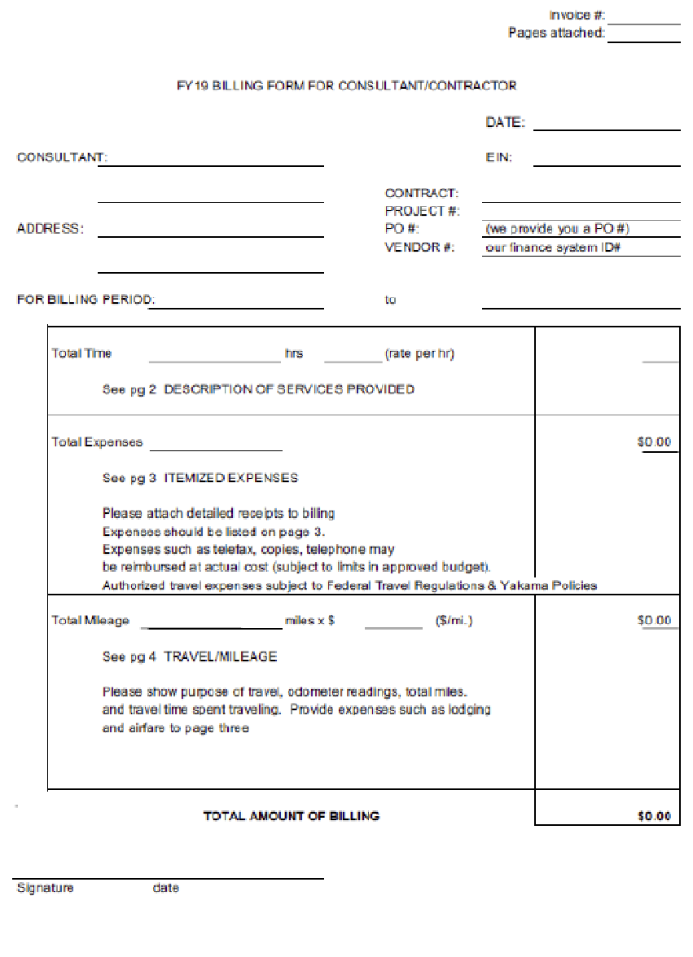
FY 24

