

Columbia River
Honor. Protect. Restore.

OFFICE
P.O. Box 151
401 Fort Road
Toppenish, WA 98948

PHONE
(509) 506-5026

EMAIL
mitr@yakamafish-nsn.gov

WEB
Yakamafish-nsn.gov Advertisement and Notes for BIDS
Starvation Flats Phase 3 Meadow Restoration, Yakama Reservation
November 5th, 2025
Dear Contractor:
The Yakama Reservation Watershed Project is requesting bids for the Starvation Flats Phase 3 Meadow Restoration Project to be implemented in summer 2026. The meadow is located within the Yakama Nation closed area. The project will involve all work elements and specifications found in the Project Plans attached to this bid packet.
If interested in the award of this contract you must attend the only pre-bid site visit scheduled on November 14, 2025. The group will depart from the Fisheries Resource Office (4690 SR 22 Toppenish, WA) at 10:00 AM. Please include the license plate number/make/model/year of the vehicle you plan to bring to the tour and the names of staff attending from your organization with your RSVP. All vehicles will be checked in at the Closed Area guard station the day of the tour.
Request for Proposal – MUST BE MAILED AND EMAILED TO BE CONSIDERED.
By the close of business on Monday December 15th, 2025 at 5:00 pm PST, each contractor that wishes to be considered must have completed and submitted to the Yakama Nation a signed hardcopy of the Project Bid Sheet along with all required supporting documentation. Please specify in writing on the bid sheet that prices will be valid for at least 180 days. All competitive bid materials must be sent by parcel delivery service or postal mail to:

Yakama Nation Fisheries  Attn: Debbie Azure  RE: Starvation Flats Phase 3 Project  PO Box 151  Shipping Address: 401 Fort Road  Toppenish, WA, 98948 | Please note that we recommend getting completed bids in the mail by one week prior to the RFB deadline to ensure delivery on time. We also recommend that you email Debbie Azure (azud@yakamafish-nsn.gov) a digital copy of your final bid documents as well as a copy of your mailing receipt for proof of submission. Make sure the receipt lists the name and address of the sender and correct details for the intended recipient.

Please email electronic bid proposals with the email subject as: Starvation Flats 3 Meadow Restoration Construction Bid – Name of Firm. Send to the following:

Debra Azure, azud@yakamafish-nsn.gov
Email verification will be sent to confirm receipt of proposal submission.

For technical questions ONLY regarding the RFP (do not email proposals to):
Document the email subject as: Starvation Flats 3 Construction Bid Question – Name of Firm. Send to the following:
- Becca Mitre, mitr@yakamafish-nsn.gov, (509) 506-5026
- Brandon Rogers, rogb@yakamafish-nsn.gov, (509) 949-4109

Key Dates:
- Site Tour (RSVP by November 10th 2025 - 5:00 PM), November 14th 2025, 10:00 AM
- Bid Submission Deadline: December 15th 2025 - 5:00 PM
- Contractor selection: approximately December 19th 2025
- Contract and scope review with selected contractor: January 12th 2026
- Contract is fully signed: approximately January 30th 2026

All contractors submitting bids for this project shall provide and/or demonstrate, at a minimum, the following:
- A list of experienced equipment operators that will be on-site during project construction. Please provide details of their work on habitat/meadow restoration projects within the past several years.
- A detailed construction timeline of how you propose to get all project tasks completed within the stated project timeline that is provided within the engineered design set.
- Experience and examples of previously completed habitat/meadow restoration projects with similar scopes of work.
- A list of key pieces of heavy equipment that will be used in construction of the project and a daily standby rate for each piece of heavy equipment.

Please note:
- Davis Bacon Wages apply to this contract. The winning contractor will adhere to the Davis Bacon rules and comply and submit all necessary paperwork to the Yakama Nation.
- TERO fees and requirements apply to this project

- The Yakama Nation is exempt from state taxes on this project. Please see the attached Treaty Fishery Exempt Cover Letter and Treaty Fishery Exempt Certificate. The winning contractor will receive signed copies for their records.

- This project has adopted by reference in the Engineer's Planset the 2025 Washington State Department of Transportation (WSDOT) Standard Specifications for Road, Bridge, and Municipal Construction. You can download a digital copy of the WSDOT 2025 Standard Specifications at: https://www.wsdot.wa.gov/publications/manuals/fulltext/M41-10/SS.pdf

- The winning contractor will have all equipment cleaned and inspected prior to entering the any portion of the project site.

- Awarded contractor must provide “san-a-can” service.

- Industrial Fire Precaution Levels (IFPL): The project area is located in IFPL Zone 680. On the rare occasion that Zone 680 goes to Level III – Partial Shutdown, Yakama Nation will obtain a waiver to continue work if safe.

EXHIBIT A
SCOPE OF WORK
Starvation Flats Meadow Restoration Project, Phase 3
Project Description
The Yakama Nation’s Yakima Reservation Watersheds Project (YRWP) is soliciting bids for a meadow restoration project in Starvation Flats meadows (Township 9N Range 13E Section 27) near White Swan, WA. See Figure 1 for a general location of the project area on the reservation. Phase 3 of the project is funded by the Bureau of Indian Affairs. Accordingly, all federal requirements for contracting will apply to this project.
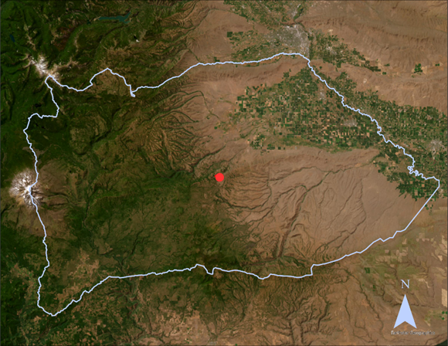
Figure 1. General location of the project site within the Yakama Reservation boundary.
This project involves the construction of a valley grade control structure, ditch plugs with relief, and road improvements along the access routes. Work will take place within the ordinary high water mark of unnamed tributaries to North Fork Dry Creek. The project has been designed by Inter-Fluve, Inc., which is a civil engineering firm with extensive experience in design and installation of habitat and restoration structures in various landscapes and river systems. Oversight engineers, staff and YRWP Biologist(s) will provide field-direction to finalize locations and adjust construction of treatment structures to accommodate local site conditions.

Scope of Work-Contractor Tasks
John Gaffney, (PE, Interfluve, Inc.) is the licensed engineer of record for this project.
The following tasks are outlined in the budget table for bidding. Please note a TERO fee of 3% is applied to the project cost, and is included in the bid sheet (Exhibit B).
Please see the attached Final Designs for more specifications on work elements.
- General Requirements
General requirements include mobilization, demobilization, insurance, and safety.
- Site Access
Temporary site access route improvements.
- Access Road Repair (as needed)
The successful contractor will make road improvements along the access route (dark pink) as needed. Most of the access road to the site has been maintained with only minor improvements needed.

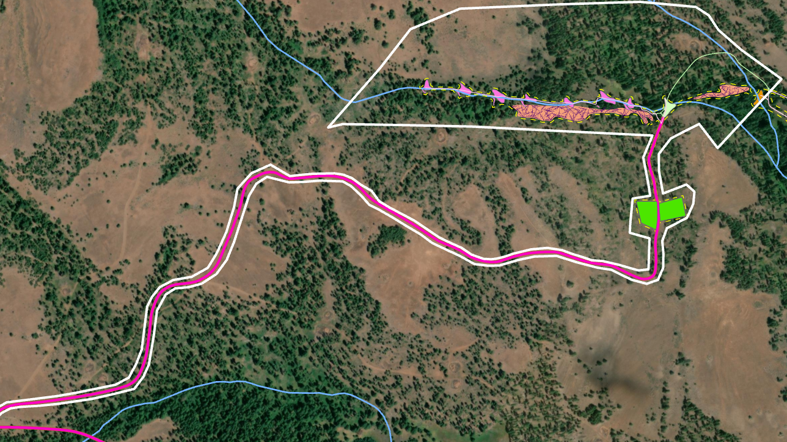
Figure 2. The primary access route to the project area shown in pink.
- Primary Access Route Extension
Major improvements will need to be made to the final portion of the primary access route closest to the project area. The existing road has been overgrown and degraded and is not suitable for access. Figure 3 shows the area along the primary access route where major improvements will be needed. The estimated length of repairs for this section of road is approximately 2000 FT.
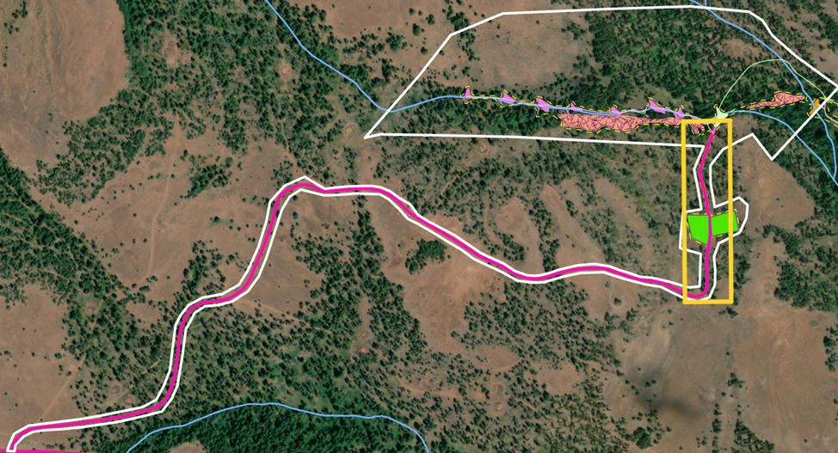
Figure 3. The final portion of the access route needed major improvements outlined in yellow.
- Valley Grade Control Structure (Station 70+00 in Planset)
A Valley Grade Control structure will be installed at the location outlined in yellow below. Please see attached planset for specifics.
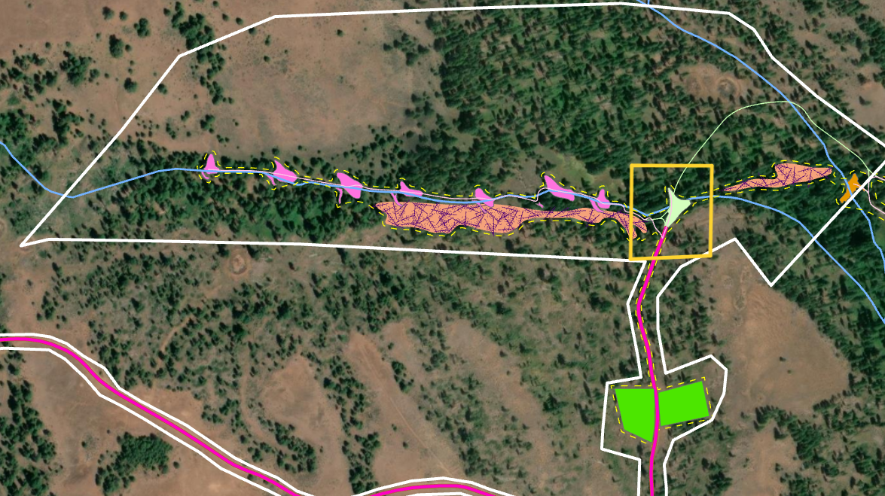
Figure 4. Map showing the location of the Valley Grade Control structure in the project area.
- Ditch Plugs with Relief (73+00 to 91+00 in Planset)
Several ditch plugs will be installed along an incised channel. Figure 5 below shows the location of the ditch plugs with relief along the channel. Please see planset for more specifics on ditch fill with reliefs.
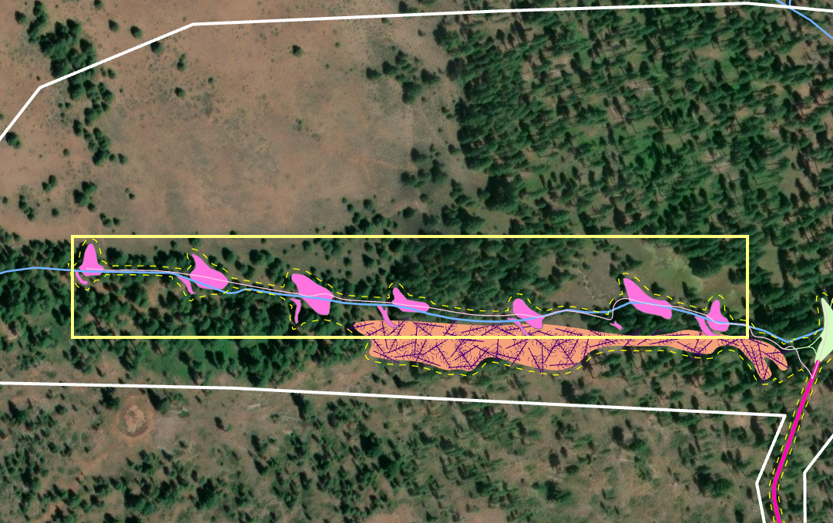
Figure 5. Location of ditch plug work elements shown in pink and outlined in yellow.
- Meadow Roughness/ Tree Cutting (Optional)
The meadow restoration includes meadow roughness which will be done by felling trees near the project area. This section of the project area is foot access only and hand carried equipment only. Trees will be dragged into position for meadow roughness. This work element is included as optional however all contractors should include an estimate in the bid form.
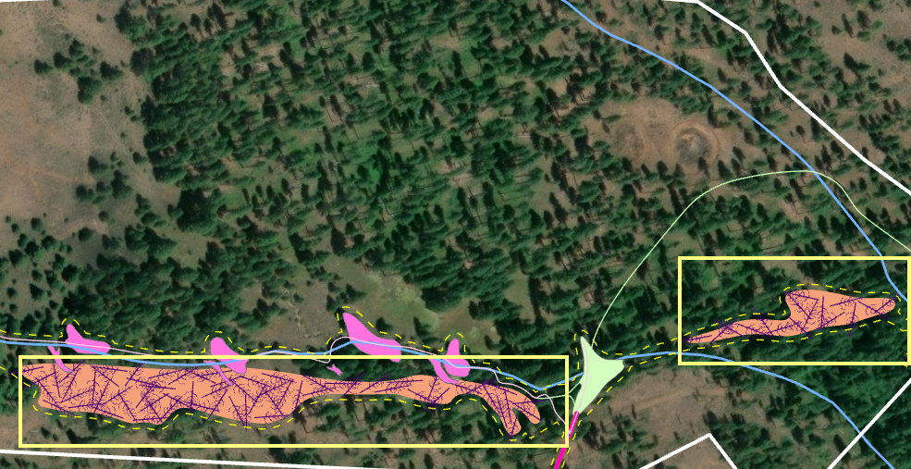
Figure 6. Map showing locations of where felled trees will be placed to create meadow roughness outlined in yellow.
- Native Plant Revegetation
Areas near the ditch plugs and staging area and temporary access roads will require seeding. Contractors will be responsible for purchasing and planting the seed mixes in the project area. Please see page 25 in the planset for seeding locations and see the updated bid sheet for accurate quantities.
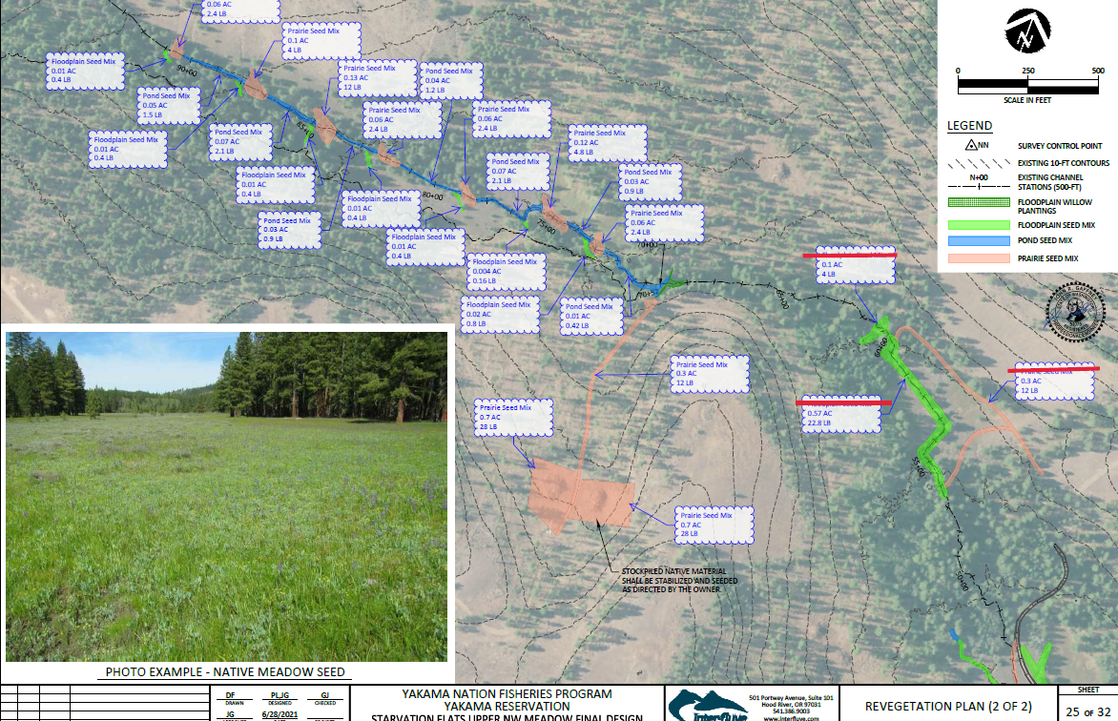
Figure 7. Revegetation Plan for Phase 3.
Construction Oversight
Engineering Firm, Interfluve, Inc. has been awarded the construction oversight contract. Furthermore, Interfluve, Inc. designed the meadow restoration project and coordinated with YRWP in the past to implement the previous phases of the Starvation Flats Meadow Restoration Project.
The designated project lead from the Yakama Nation or designated engineer from Interfluve, Inc. shall be available during all construction activities to provide the Contractor with information as required to carry out the Contract. Except as noted that the Yakama Nation shall have full authority to direct ALL work. The Yakama Nation’s Designated Representative must preapprove any deviation from specifications or instructions.
Construction Schedule
Construction is expected to occur between July and August 2026.

Bid Qualifications and Selection
Minimum Qualifications for a responsive bid:
- Contractors will RSVP for the field tour by emailing mitr@yakamafish-nsn.gov no later than November 10, 2025. The tour will depart the Yakama Nation Fish and Wildlife Building (4690 WA-22, Toppenish, WA) on November 14th at 10:00 AM.
- Any technical questions in regard to this request for proposals must be emailed to Rebecca Mitre at mitr@yakamafish-nsn.gov by November 28th. Upon receipt of an inquiry an email containing the original question and associated response from YN will be sent out to each contractor.
- Each proposal must be received by the Yakama Nation by December 15th at 5:00 PM PST. Both hard copy sent by certified mail and electronic copy of proposals must be submitted. Please send electronic copies to Debra Azure at azud@yakamafish-nsn.gov. This will remain a sealed-bid process meaning that the project lead (Rebecca Mitre) will not view proposals sent by contractors until the closing date. Debra will send a confirmation receipt to the contractor to verify official bid submission.
The bidder to whom this contract is awarded must comply with Yakama Nation’s Tribal Employment Rights Ordinance (TERO), including all applicable fees and Indian-preference subcontracting and hiring requirements.
Bids will be evaluated and scored by YN staff on the following basis:
- Demonstrated experience with this type of work (see instructions below)
- Cost
- Adequacy/ quality of staff and equipment proposed
- Completeness of bid (based on RFB submission Requirements)
- Please note that tribally owned firms are preferred.
YN Fisheries will award the Project contract to the responsive bidder whose bid conforms with all the material terms and conditions of the invitation for bids and scores the highest in the Bid Scoring Sheet (Table 1) below.

Bids will be evaluated and scored by YN staff on the following basis:
Bid Scoring Sheet | Score each category from 1 to 5, 5 being highest.
 | Scoring Criteria | Bid Score
1 | Demonstrated experience with this type of work
2 | Cost
3 | Adequacy/ quality of staff and equipment proposed
4 | Completeness of bid (based on RFB submission requirements)
5 | Tribally owned (Yes = 5 points, No = 0)
 | Total Score

Bid Instructions:
The Contractor shall submit a summary of similar construction work accomplished in Washington, with a 2-page limit for this summary of previous projects. Elements that will result in a higher score include projects with Yakama Nation, in central and eastern Washington, projects with a focus on meadow restoration, and experience in working with sensitive areas. The contractor will also provide a list of relevant staff with their qualifications and a summary of the equipment they plan to use. Lastly, the consultant will fill out the bid sheet in Exhibit B. Bids shall be considered NON-RESPONSIVE if they fail to provide satisfactory completeness of information requested in the Bid Tab (Exhibit B).

Please note:
Davis Bacon Wages apply to this contract. The winning contractor will adhere to the Davis Bacon rules and comply and submit all necessary paperwork to the Yakama Nation.
The Yakama Nation is exempt from state taxes on this project. Please see the Treaty Fishery Exempt Cover Letter and Certificate attached to the webpage for reference. The winning contractor will receive signed copies of the Cover Letter and Certificate for their records.
Limitations
The Yakama Nation reserves the right to accept or reject any and all of the proposals received as a result of this request, or to cancel in part or entirely this request if it is in the best interest of the Yakama Nation to do so. This request does not commit the Yakama Nation to pay any costs incurred in the preparation of a proposal.
Contractors Obligation
The contractor shall furnish all supervision, labor, equipment and tools necessary to complete the project as outlined in the proposed scope of work. Subcontracting will not be permitted without approval of the Yakama Nation. Please discuss any needed subcontractors with Yakama Nation designated representative to include in Contractual Agreement.
BIDDERS who wish to discuss the site in greater detail can contact YRWP staff (Rebecca Mitre (509)-506-5026, mitr@yakamafish-nsn.gov). Relevant information discussed will be shared with all perspective BIDDERS.

Designated Representatives from Yakama Nation
Rebecca Mitre
Fisheries Biologist
Work Cell: 509-506-5026
Email: mitr@yakamafish-nsn.gov

Brandon Rogers
Habitat Section Coordinator
Work Cell: 509-949-4109
Email: rogb@yakamafish-nsn.gov

EXHIBIT B: Bid Sheet

Exhibit B - Bid Form (Updated 12/01/2025)
 | Starvation Flats Meadow Restoration, Phase 3 (Yakama Nation)
 | Contractor: |  |  |  | Date:
 | Line | Item | Unit | Est. QTY | Unit Cost | Cost
 | 1.00 | General Requirements
 | 1.01 | Mobilization, including demobilization, insurance, safety | L.S. | - | N/A
 | 2.00 | Site Access
 | 2.01 | Temporary site access route improvements | L.S. | - | N/A
 | 3.00 | Access Road Repair (as needed)
 | 3.01 | Road Repair | FT | 1500
 | 4.00 | Primary Access Route Extension
 | 4.01 | Construction of primary access route extension to site | FT | 2000
 | 5.00 | Valley Grade Control (Station 70+00)
 | 5.01 | Clearing and Grubbing | AC | 0.2
 | 5.02 | Excavation, native | CY | 150
 | 5.03 | Rock for erosion and scour protection | CY | 500
 | 5.04 | Erosion control fabric | SY | 100
 | 6.00 | Ditch Plugs with Relief (73+00 to 91+00)
 | 6.01 | Clearing and Grubbing | AC | 0.9
 | 6.02 | Excavation, native | CY | 110
 | 6.03 | Backfill incl. compaction and grading relief, native | CY | 260
 | 6.04 | Backfill incl. compaction and grading relief, import | CY | 1980
 | 6.05 | Erosion control fabric | SY | 2,400
 | 7.00 | Tree Cutting (Optional)
 | 7.01 | Tree Cutting | AC | 2
 | 8.00 | Native Plant Revegetation
 | 8.01 | Revegetation, Pond Seeding | AC | 0.4
 | 8.02 | Revegetation, Prairie Seeding | AC | 1.5
 | 8.03 | Revegetation, Floodplain Seeding | AC | 0.1
 | 9.00 | Native Plant Seed Estimates
 | 9.01 | Pond Seed Mix | LBS | 15
 | 9.02 | Prairie Seed Mix | LBS | 80
 | 9.03 | Floodplain Seed Mix | LBS | 4
 |  | Construction Subtotal:
 |  | Tribal Employment Rights Ordinance (TERO) Fee (3% of subtotal):
 |  | Construction Total (Bid):
 |  | L.S. - lump sum, YDS - Yards, AC - Acres, CY - Cubic Yards, SY - Square Yards FT - Feet

Printed Name and Title Signature

PAYMENT SCHEDULE

Bills may be submitted for payment once the Yakama Nation has verified completion.
Ten percent (10%) of the amount billed shall be retained until a final release has been signed by the contractor and delivered to the Yakama Nation and all work has been completed as outlined above.

1. Payment Schedule

Progress: The Contractor shall submit a separate bill for each major project task element after the work has been completed, reviewed and accepted by Yakama Nation’s Designated Representative. The Contractor is encouraged to invoice monthly when payment is necessary.

Percentage: The Contractor shall invoice monthly and will be allowed to submit a bill for percentage of work completed after the work has been reviewed and accepted by Yakama Nation’s Designated Representative.

Actual Work Completed: The Contractor shall invoice monthly and will be allowed to submit a bill for actual work completed.

Alternative Schedule: The Contractor shall invoice and be allowed to submit a bill as follow:

2. Tax Exempt Certificate

Due to the location and nature of the Services being provided by Contractor:

The Contractor has not been given a Tax Exemption Certificate

The Contractor has been given a single use Tax Exemption Certificate. Due to the nature of this Agreement, as set forth below, the Contractor should be allowed to use the tax-exempt certificate that is included with this document.

  - Fisheries Management Through Salmon Habitat Restoration

EXHIBIT D: EXAMPLE CONTRACTUAL AGREEMENT

Between:

THE CONFEDERATED TRIBES AND BANDS OF THE YAKAMA NATION
on behalf of its program or department
P.O. Box 151 / 401 Fort Road
Toppenish, WA 98948
General Phone: (509) 865-5121
Program Phone:
(hereafter “Yakama Nation”)

And

[CONTRACTOR NAME]
Address Line 1
Address Line 1
Phone:
(hereafter “Contractor”)

This Construction Services Agreement (“Agreement”) is executed by and between Contractor and Yakama Nation, a federally recognized sovereign Nation pursuant to the Treaty with the Yakamas of 1855 (12 Stat. 951). Contractor and Yakama Nation may be collectively referred to herein as the “Parties,” and each may be referred to as a “Party.”

1. TERM

The effective term of this Agreement shall be from __________, through December 31, 2025, absent a valid termination action in accordance with the express terms of this Agreement.

2. PERFORMANCE

Contractor agrees to perform the services set forth in the attached scope of work, Exhibit “A” (collectively, the “Services”), which is incorporated by reference in this Agreement.

3. COMPENSATION

A. Maximum Compensation. The total compensation amount approved by Yakama Nation for this Agreement is limited to, and shall not exceed ($ ); which amount shall include any and all compensation for the Services as described herein and set forth in detail in the budget attached as Exhibit “B”. If Exhibit “B” describes separate and specific maximum compensation amounts for services and expenses, then at the end of the term of this Agreement, any remaining balance in the amount allocated for expenses may be used by Yakama Nation, at its sole discretion, to cover fees for authorized services, so long as the total compensation amount set forth above is not exceeded.

B. Invoicing, Progress Reports and Payment of Compensation. Yakama Nation shall compensate Contractor according to the billing rate(s) and/or fee schedule(s) set forth in Exhibit “B” in an amount not to exceed that stated above. Contractor shall submit monthly invoices and appropriate supporting documentation to Yakama Nation, including a progress report that provides of brief summary of daily activities associated with services performed and completed by Contractor. Unless the Parties agree in writing to different terms, invoice periods shall begin on the first day of each month and end on the last day of each month. Invoices shall be submitted by Contractor to Yakama Nation’s designated staff contact within fifteen (15) days after the end of the month in which the services were provided and/or expenses were incurred. Contractor waives the right to receive full payment on invoices submitted more than sixty (60) days following the end of the proper invoice period. If a question or concern arises regarding an item on an invoice, Yakama Nation shall notify Contractor of the question or concern. Within five (5) business days following such notification, Contractor shall take action to sufficiently explain or correct the item, or Contractor shall be deemed to have waived their right to demand payment for the item.

C. Availability of Funds. Notwithstanding any other provisions of this Agreement, Contractor understands and agrees that compensation for services and expenses under the terms of this Agreement shall be contingent upon the availability of funds (a) placed to the credit of Yakama Nation in the Treasury of the United States, (b) appropriated by Congress, or (c) from local funds maintained in the name of Yakama Nation.

D. Federal & Grant Funds. Contractor understands and agrees that agreements and contracts funded by federal funds or other grant funds may be subject to certain legal requirements. These may include, but are not limited to, those requirements set forth in the United States Office of Budget Management’s Uniform Guidance, 2 C.F.R. Part 200, and/or the terms of an applicable source grant. Contractor agrees to comply with and utilize funds in accordance with all applicable laws, regulations, and guidelines, and with any applicable grant or contract terms, and further understands and agrees that the use of such funds may be subject to audit by the grantor agency. Contractor shall reimburse Yakama Nation for any costs of Contractor that are disallowed by a grantor.

4. PROPERTY DEVELOPED BY CONTRACTOR

Contractor agrees that it will retain no interest in the information, data, proposals, papers, copyrights, patents, or any other material or property developed, discovered, invented, and/or accumulated by Contractor in connection with the performance of this Agreement. Subject to applicable law, Contractor shall turn over such information, data, proposals, papers, copyrights, patents, discoveries, inventions, and other material or property to Yakama Nation upon the expiration or termination of this Agreement or upon request.

5. PUBLICATION OF INFORMATION

The dissemination or publication of documents, information material or other property developed or generated by Contractor during the course of this Agreement shall require the written approval of Yakama Nation.

6. RECORDS

A. Access. Subject to applicable law, Yakama Nation will provide Contractor with reasonable access to its personnel, facilities, and records necessary to the performance of this Agreement.

B. Maintenance & Retention of Records; Financial Management for Accounting and Audits. Contractor shall maintain and retain auditable records during the term of this Agreement and for a period of at least three (3) years following the expiration or termination of this Agreement. Contractor shall maintain its records to comply with the Audit Act of 1984, P.L. 98-502 (31 U.S.C. § 7501 et. seq., as amended) and the Office of Management and Budget’s Uniform Guidance requirements set forth at, 2 C.F.R. part 200, Subpart F, as amended. Contractor shall adhere to a systematic accounting method that assures timely and appropriate resolution of audit findings and recommendations in compliance with the Uniform Guidance. Subject to applicable law, Contractor agrees that Yakama Nation, the grantor agency (if applicable), the Comptroller General of the United States, or any of their duly authorized representatives, shall have timely access to Contractor’s records which are pertinent to the subject matter of this Agreement and the performance of obligations contained herein, for the purpose of conducting an audit and/or examination, and/or creating excerpts and/or transcriptions.

7. INDEPENDENT CONTRACTORS

Contractor shall employ, at is own expense, all personnel and equipment reasonably necessary to perform the Services called for by this Agreement. Such personnel shall not be considered Yakama Nation employees. Contractor shall be responsible to ensure that all personnel engaged in performing Services are fully qualified to undertake the work in accordance with applicable tribal, federal, state, and local laws. Contractor shall at all times in performance of this Agreement operate as, and have the status of, an independent contractor, and will not be an agent or employee of Yakama Nation; nor will Contractor or its personnel be entitled to any employee benefits provided by Yakama Nation. The Parties are not engaged in a joint venture or partnership. Neither party can represent or bind the other. Unless otherwise expressly agreed, Contractor shall be solely responsible to secure and pay for any necessary or appropriate permits, fees, licenses, inspections, or other prerequisites necessary for proper performance of the Services called for by this Agreement.

8. SUBCONTRACTING

A. Contractor shall not be permitted to hire a subcontractor to perform the Services called for by this Agreement without express prior written consent. Any unauthorized attempt by Contractor to subcontract for such Services shall be null and void, and Contractor shall be responsible for all expenses, fees, and costs associated with any such unauthorized subcontract.

B. An award of this Agreement based on a bid or proposal naming specific subcontractors and identifying the portions of the work to be performed by the subcontractors shall constitute prior written consent to the hiring of the named subcontractor(s). Subcontractor selection and subcontractor employment shall be subject to applicable TERO and Indian Preference requirements described above. Contractor shall be responsible to ensure their subcontractors are in compliance with Yakama Nation TERO and Indian Preference requirements.

9. ASSIGNMENT OF INTEREST

Contractor shall not assign its interest in this Agreement, or any part thereof, including its right to receive payment for services performed, to another party. Any attempt by Contractor to assign any obligations, rights, or fees under this Agreement will be null and void, and Contractor shall be responsible for all expenses, fees, and or costs associated with any unauthorized assignment.

10. INDEMNIFICATION

Contractor shall, at its sole expense, hold harmless, indemnify, and defend Yakama Nation and its officers, agents, employees, and assigns against any and all losses, costs, damages, expenses or other liabilities whatsoever, including reasonable attorney’s fees and expenses, that arise out of or are connected with, directly or indirectly, Contractor’s actions or omissions, or Contractor’s agents’ acts or omissions related to this Agreement, including, but not limited to, accidents or injuries to persons or property.

11. SITE INVESTIGATION AND CONDITIONS AFFECTING THE WORK

A. Contractor acknowledges that it has taken steps reasonably necessary to ascertain the nature and location of the work, and that it has investigated and satisfied itself as to the general and local conditions which can affect the work or its cost, including but not limited to:

(1) Conditions bearing upon transportation, disposal, handling, and storage of materials;
(2) The availability of labor, water, electric power, and roads;
(3) Uncertainties of weather, river stages, tides, or similar physical conditions at the site;
(4) The conformation and conditions of the ground; and
(5) The character of equipment and facilities needed preliminary to and during work performance.

Contractor also acknowledges that it has satisfied itself as to the character, quality, and quantity of surface and subsurface materials or obstacles to be encountered insofar as this information is reasonably ascertainable from an inspection of the site, including all exploratory work done by Yakama Nation and information available to the public from local government agencies, as well as from the drawings and specifications made a part of this Agreement. Any failure of Contractor to take the actions described and acknowledged in this paragraph will not relieve Contractor from responsibility for properly estimating the difficulty and cost of successfully performing the work, or for proceeding to successfully perform the work without additional expense to Yakama Nation.

B. Yakama Nation assumes no responsibility for any conclusions or interpretations made by Contractor based on the information made available by Yakama Nation. Nor does Yakama Nation assume responsibility for any understanding reached or representation made concerning conditions that can affect the work by any of its officers or agents before the execution of this Agreement, unless that understanding or representation is expressly stated in this Agreement.

12. PHYSICAL DATA

Data and information furnished or referred to below or in the attached exhibits is for Contractor’s information. Yakama Nation shall not be responsible for any interpretation of or conclusion drawn from the data or information made available to Contractor. Further, Yakama Nation specifically does not warrant construction methodology that may be included in such documents.

(a) The indications of physical conditions on any drawings or specifications that have been provided are the result of general inspection of the site. Please see the attached exhibits

(b) n/a

13. SCHEDULE FOR CONSTRUCTION

A. Construction Schedule. Unless the construction schedule is specifically addressed elsewhere in this Agreement, Contractor shall, within five (5) days after the work commences on the Agreement or another period of time determined by Yakama Nation, prepare and submit to Yakama Nation three (3) copies of a practicable schedule showing the order in which Contractor proposes to perform the work, and the dates on which Contractor contemplates starting and completing the several salient features of the work (including acquiring materials, plant, and equipment). The schedule shall be in the form of a progress chart of suitable scale to indicate appropriately the percentage of work scheduled for completion each week during the Agreement period. If Contractor fails to submit a schedule within the time prescribed, Yakama Nation may withhold approval of progress payments until Contractor submits the required schedule. Should Contractor fall behind its schedule, a revised schedule shall be forwarded with the next Contractor’s request for progress payment. Additional schedules shall be furnished to Yakama Nation as soon as practicable if so requested.

B. Rate of Progress. With any and each partial payment request, Contractor shall submit a copy of the last submitted schedule annotated to indicate actual progress made to date. If at any time, in the opinion of Yakama Nation, Contractor has fallen behind the schedule to an extent which would jeopardize timely completion, Contractor shall take the steps necessary to improve its progress, including those that may be required, to enable timely completion without additional cost to Yakama Nation. Such steps may include, but are not limited to, increasing the number of shifts, the amount of overtime, days of work per week, and/or the amount of construction plant being utilized. Contractor shall submit any supplementary schedules Yakama Nation deems necessary to demonstrate how the rate of progress necessary for timely completion will be regained.

C. Breach. Failure of Contractor to comply with the requirements of this section shall be considered a material breach and grounds for a determination by Yakama Nation that Contractor is not prosecuting the work with sufficient diligence to ensure completion within the time specified in the Agreement. Upon making this determination, Yakama Nation may terminate Contractor’s right to proceed with the work, or any separable part of it, in accordance with the default terms of this Agreement.

14. DIFFERING SITE CONDITIONS

Contractor shall promptly, and before the conditions are disturbed, give a written notice to Yakama Nation of (1) subsurface or latent physical conditions at the site which differ materially from those indicated in this Agreement, or (2) unknown physical conditions at the site, of an unusual nature, which differ materially from those ordinarily encountered and generally recognized as inherent to the type of work provided for in the Agreement. Unless specifically identified in the Agreement, discoveries of archaeological or historical remains such as graves, fossils, skeletal materials and artifacts protected by the Archaeological Resources Protection Act (36 CFR 1214) are considered type 2 conditions.

15. LAYOUT OF WORK

Contractor shall lay out its work from Yakama Nation established base lines and bench marks indicated on the drawings or any other manner furnished by Yakama Nation. Contractor shall be responsible for all measurements in connection with the layout. Contractor shall furnish, at its own expense, all stakes, templates, platforms, equipment, tools, materials, and labor required to lay out any part of the work. Contractor shall be responsible for the execution of the work to the lines and grades that may be established or indicated by Yakama Nation. Contractor shall also be responsible for maintaining and preserving all stakes and other marks established by Yakama Nation until authorized to remove them. If such marks are destroyed by Contractor or through its negligence before their removal is authorized, Yakama Nation may replace them and deduct the expense of the replacement from any amounts due or to become due to Contractor.

16. SPECIFICATIONS, DRAWINGS AND MATERIAL SUBMITTALS

A. Omissions from any drawings and specifications that have been provided, or the misdescription of details of work which are manifestly necessary to carry out the intent of the drawings and specifications, or which are customarily performed, shall not relieve Contractor from performing such omitted or misdescribed details of the work. Work shall be performed as if fully and correctly set forth and described in the drawings and specifications.

B. Contractor shall check all drawings furnished by Yakama Nation prior to starting work and shall promptly notify Yakama Nation of any discrepancies. Figures marked on drawings shall in general be followed in preference to scale measurements. Large-scale drawings shall in general govern small-scale drawings. Contractor shall compare all drawings and verify the figures before laying out the work, and will be responsible for any errors which might have been avoided thereby.

17. MATERIAL & WORKMANSHIP

A. Materials. All equipment, material, and articles incorporated into the work covered by this Agreement shall be new and of the most suitable grade for the purpose intended, unless otherwise specifically provided in this Agreement. Use of recycled materials for the manufacture of such products is encouraged. Equipment, material, or articles specified by trade name, make, or catalog number, shall be provided. Equivalent items are not acceptable unless specifically authorized in the specification.

B. Professional Work. All work under this Agreement shall be performed in a professional, thorough, skillful, and safe manner, and shall be consistent with relevant professional standards. Yakama Nation may require, in writing, that Contractor remove from the work any employee Yakama Nation deems incompetent, unsafe, or otherwise objectionable.

C. Legally Compliant Work. In performing its obligations under this Agreement, Contractor shall comply with all applicable tribal, federal, state and local laws, regulations, guidelines and policies in performance of services under this Agreement. Such laws may include, but are not limited to, the Davis Bacon Act and related federal labor law requirements associated with federally funded construction projects. Contractor represents that it has reviewed, and is familiar with, all laws relevant to the performance of services under this Agreement.

18. SUPERINTENDENCE BY THE CONTRACTOR

At all times during performance of this Agreement, and until the work is completed and accepted, Contractor shall directly superintend the work or assign and have on the worksite a competent superintendent who is satisfactory to Yakama Nation and has authority to act for Contractor.

19. PERMITS AND RESPONSIBILITIES

Unless otherwise provided in this Agreement, Contractor shall, without additional expense to Yakama Nation, be responsible for obtaining any and all necessary licenses and permits, and for complying with any tribal, federal, state, and municipal laws, codes, and regulations applicable to the performance of the work. Contractor shall also be responsible for all damages to persons or property that occur as a result of Contractor’s fault or negligence, and shall take proper safety and health precautions to protect the work, the workers, the public, and the property of Yakama Nation and others. Contractor shall also be responsible for all materials delivered and work performed until completion and acceptance of the entire work, except for any completed unit of work which may have been accepted under this Agreement.

20. OTHER CONTRACTS

Yakama Nation may undertake or award other contracts for additional work, or may utilize in-house construction forces, at or near the site of the work. Contractor shall fully cooperate with such other contractors and Yakama Nation employees, and carefully adapt scheduling and performance of the work under this Agreement to accommodate simultaneous performance, heeding any direction that may be provided by Yakama Nation. Contractor shall not commit or permit any act which will interfere with the performance of work by any other contractors or by Yakama Nation employees.

21. USE AND POSSESSION PRIOR TO COMPLETION

Yakama Nation shall have the right to take possession of or use any completed or partially completed part of the work call for by this Agreement. Before taking possession of or using any work, Yakama Nation shall furnish Contractor a list of items of work remaining to be performed or corrected on those portions of the work that Yakama Nation intends to take possession of or use. However, failure of Yakama Nation to list any item of work shall not relieve Contractor of responsibility for complying with the terms of this Agreement. Yakama Nation’s possession or use shall not be deemed an acceptance of any work under this Agreement.

22. CLEANING UP

A. Contractor shall at all times keep the work area, including storage areas, free from accumulations of waste materials. Before completing the work, Contractor shall remove from the work and premises any rubbish, tools, scaffolding, equipment, and materials that are not the property of the owner of the underlying real property. Upon completing the work, Contractor shall leave the work area in a clean, neat, and orderly condition satisfactory to Yakama Nation.

B. Unless specifically set forth in the Agreement, Contractor shall not burn any material on site, on the right-of-way or on the access roads to the sites. All material and debris shall be hauled to an appropriate disposal site.

23. ROAD MAINTENANCE

Contractor shall maintain all roads used by it, and upon completion of the job shall leave them in as good a condition as when first used. A road-grading machine (not a bulldozer) shall be used for maintenance and final grading. In no event shall Contractor interfere with the property owner’s use of roads existing prior to Contractor’s entry.

24. STOP WORK ORDER

A. Yakama Nation may order Contractor to suspend all or any part of the work call for by this Agreement for the period of time that Yakama Nation determines appropriate for the convenience of Yakama Nation.

B. Contractor shall immediately comply with Yakama Nation’s order and take all reasonable steps to minimize the incurring of costs allocable to the work covered by the order.

25. PROTECTION OF EXISTING VEGETATION, STRUCTURES, AND IMPROVEMENTS

A. Contractor shall preserve and protect all structures, equipment, utilities, other improvements, and vegetation (such as trees, shrubs, and grass) on or adjacent to the work site, which are not to be removed and which do not unreasonably interfere with the work required under this Agreement. Contractor shall only remove trees when specifically authorized to do so, and shall avoid damaging vegetation that will remain in place. If any limbs or branches of trees are broken during performance of this Agreement, or by the careless operation of equipment, or by workers, Contractor shall trim those limbs or branches with a clean cut and paint the cut with a tree-pruning compound as directed by Yakama Nation’s representative.

B. If Contractor fails or refuses to repair the damage promptly, Yakama Nation may have the necessary work performed and charge the cost to Contractor.

26. INSURANCE

A. The following minimum kinds and amounts of insurance are applicable in the performance of the work under this Agreement. Contractor shall (subject to applicable law) maintain such insurance, naming Yakama Nation as an additional insured:

(1) Workers’ compensation and employer’s liability. Contractor is required to comply with applicable Federal and State workers compensation and occupational disease statutes. Employer’s liability coverage of at least $100,000 shall be required.

(2) General liability. Contractor shall provide general liability insurance of at least $1,000,000 per occurrence/$2,000,000 aggregate. Any policy aggregate limits which apply, shall be modified to apply to each location and project. The policy shall name Yakama Nation, its officials, officers, employees and agents, as insureds with respect to Contractor's performance of services.

(3) Automobile liability. Contractor shall provide automobile liability insurance covering the operation of all automobiles used in the performance of this Agreement. Policies shall provide limits of at least $1,000,000 per accident and include coverage for all owned, non-owned and hired automobiles. Contractor’s policy shall be primary to any insurance of Yakama Nation.

(4) Environmental impairment liability. Contractor shall provide environmental impairment liability insurance of at least $1,000,000 per occurrence. Such insurance will include coverage for the clean up, removal, storage, disposal, transportation and/or use of pollutants. The insurance policy shall name Yakama Nation, its officials, officers, employees and agents as insured. Contractor’s policy shall be primary to any insurance of Yakama Nation.

B. Contractor may, with the approval of Yakama Nation, maintain a self-insurance program; provided that, with respect to workers’ compensation, Contractor is qualified pursuant to statutory authority.

C. Before commencing work under this Agreement, Contractor shall provide to Yakama Nation certificates of insurance from the insurance company stating the insurance required has been obtained and is in force. The certificate(s) shall identify Contractor and the contract(s) for which coverage is provided, and shall contain a statement that the insurer will give notice of cancellation or any material change to Yakama Nation at least thirty (30) days before the effective date. In addition, Contractor shall provide certificates as the policies are renewed throughout the period of this Agreement. If Contractor’s insurance does not cover the subcontractors involved in the work, Contractor shall provide certificates stating that the required insurance has been obtained by the subcontractors.

27. INSPECTION - SERVICES AND CONSTRUCTION

A. Yakama Nation may inspect the work called for by this Agreement at any time and place. Where possible and practicable, Yakama Nation will perform inspections in a manner that will not unduly delay the work.

B. If any of the services do not, in Yakama Nation’s sole reasonable opinion, conform with the requirements of this Agreement, or with applicable laws, regulations or governmental policies, then Yakama Nation may require the Contractor to perform the services again in conformity at no cost to Yakama Nation. When the defects in services cannot be corrected by re-performance, Yakama Nation may deduct from the Agreement payments an amount which reflects the reduced value of the services performed. Further, and without limiting any other remedies that Yakama Nation may have under this contract or at law, Yakama Nation may, at its sole discretion, withhold up to 10% of the total contract amount as a retainage where: (i) the total amount of this contract is $250,000 or more, or (ii) Yakama Nation in its sole discretion is concerned that satisfactory progress is not being made, or (iii) Yakama Nation is reasonably concerned that Consultant’s work is not being performed in conformance with this Agreement. At its discretion, Yakama Nation may, as applicable, hold such retainer either until the entire project is substantially completed by Contractor or until Yakama Nation’s concerns about Contractor’s performance have been resolved.

C. Neither inspection, lack of inspection, acceptance, nor payment shall relieve the Contractor of any of its obligations under this Agreement. Yakama Nation’s actions to exercise its rights under this Agreement, or to support the completion of the project consistent with the terms of this Agreement, shall not relieve the Contractor of any of its obligations under this Agreement. Contractor’s duty to re-perform non-conforming work is intended to survive the expiration of this Agreement’s term, and shall apply even where non-conformance is discovered following its expiration.

D. If Contractor does not promptly replace or correct rejected work, Yakama Nation may (without limiting any other legal or equitable remedies available to it) (1) by contract or otherwise, replace or correct the work and charge the cost to Contractor, and may (2) terminate this Agreement for default.

E. Unless otherwise specified in the Agreement, acceptance by Yakama Nation will be in writing and shall be made as promptly as practicable after completion and inspection of all work called by this Agreement or that portion of the work Yakama Nation determines can be accepted separately. Acceptance shall be final and conclusive except for latent defects, fraud, gross mistakes amounting to fraud, non-compliance with applicable law, or Yakama Nation’s rights under any warranty or guarantee.

28. WARRANTY - CONSTRUCTION

A. In addition to any other warranties in this Agreement, Contractor warrants, except as provided in paragraph (H)(1) of this clause, that work performed by it and/or its subcontractors under this Agreement conforms to applicable law and to the contract requirements, and is free of any defect in equipment, material, or design furnished, or workmanship performed by Contractor or any subcontractor or supplier at any tier.

B. This warranty shall continue for a period of three (3) years from the date of final acceptance of the work. If Yakama Nation takes possession of any part of the work before final acceptance, this warranty shall continue for a period of three (3) years from the date Yakama Nation takes possession.

C. Contractor shall remedy at Contractor’s expense any failure to conform, or any defect. In addition, Contractor shall remedy at Contractor’s expense any damage to Yakama Nation-owned or controlled real or personal property, when that damage is the result of:

(1) Contractor’s failure to conform to applicable law or contract requirements; or

(2) Any defect of equipment, material, workmanship, or design furnished by Contractor.

D. Contractor shall restore any work damaged in fulfilling the terms and conditions of this clause. Contractor’s warranty with respect to work repaired or replaced will run for three (3) years from the date of repair or replacement.

E. Yakama Nation shall notify Contractor, in writing, within a reasonable time after the discovery of any failure, defect, or damage.

F. If Contractor fails to remedy any failure, defect, or damage within a reasonable time after receipt of notice, Yakama Nation shall have the right to replace, repair, or otherwise remedy the failure, defect, or damage at Contractor’s expense.

G. With respect to all warranties, express or implied, from subcontractors, manufacturers, or suppliers for work performed and materials furnished under this Agreement, Contractor shall:

(1) Obtain all warranties that would be given in normal commercial practice;

(2) Require all warranties to be executed, in writing, for the benefit of Yakama Nation, if directed by Yakama Nation; and

(3) Enforce all warranties for the benefit of Yakama Nation, if directed by Yakama Nation.

H. Unless a defect is caused by the negligence of Contractor or subcontractor or supplier at any tier, Contractor shall not be liable for the repair of any defects of material or design furnished by Yakama Nation nor for the repair of any damage that results from any defect in Yakama Nation-furnished material or design.

(1) This warranty shall not limit Yakama Nation’s rights under the Inspection and Acceptance clause of this Agreement with respect to latent defects, gross mistakes, or fraud.

29. TAXES

The compensation for Services performed under this Agreement shall include all applicable Tribal, Federal, State, and local taxes and duties. Depending on the location and nature of the Services provided, when applicable, Yakama Nation shall provide Contractor a single use Tax Exemption Certificate.

30. TERMINATION

A. Notice. Yakama Nation may terminate all or any part of this Agreement, at any time, with or without cause, upon written notice to Contractor. Upon receipt or the termination notice, Contractor shall promptly stop work on the terminated portion of the Agreement. Contractor obligations shall be consistent with those set forth above in the Stop Work Order clause of this Agreement.

B. Breach. In the event of termination for breach or violation of the terms and provisions of this Agreement, Yakama Nation, to the extent permitted by applicable law, shall be entitled to enforce its rights under this Agreement, and recover its court costs and reasonable attorney’s fees, as determined by the court. The foregoing shall not in any way limit or restrict any right or remedy at law or equity which would otherwise be available to Yakama Nation, including, but not limited to, the right to contract with other qualified persons to complete the performance of services identified in or called for by this Agreement.

C. Termination By Tribal Council Executive Committee. Notwithstanding anything herein to the contrary, Contractor understands and agrees that the Yakama Nation Tribal Council Executive Committee may immediately terminate this Agreement by written notice.

D Effect of Complete Termination. Upon the complete termination of this Agreement, the liability of the Parties for the further performance of this Agreement shall cease, but the Parties shall not be relieved of the duty to perform their obligations up to the date of termination.

E. Effect of Partial Termination. The compensation amount shall be revised as a result of a partial termination under this section. On fixed-price contracts the revised amount shall not exceed the pre-termination contract price plus reasonable termination expenses. On cost-reimbursement contracts the revised amount shall not exceed the total of allowable and allocable costs of performance prior to termination plus termination expenses plus an adjustment of the fee on the terminated portion of the Agreement. No payment will be made for anticipated profits on the terminated portion, or consequential damages, of this Agreement. Contractor shall submit a settlement proposal within thirty (30) days of the notice of termination.

31. FORCE MAJEURE

This Agreement is subject to force majeure, and is contingent on strikes, accidents, acts of God, weather conditions, fire regulations, the actions of any government, including funding and/or budgetary decisions, and other circumstances which are beyond the control of the parties. If the terms and conditions of this Agreement are unable to be performed as a result of any cause of force majeure, then this Agreement shall be void, without penalty to any party for such non-performance.

32. NOTICE

Notice to Contractor shall consist of a letter, delivered postage prepaid, addressed to:

[Contractor’s Legal Agent’s Name]
[Contractor Name]
[Address No. 1]
[Address No. 2]

Notice to Yakama Nation shall consist of a letter, delivered postage prepaid, addressed to:

Gerald Lewis, Chairman
Yakama Tribal Council
PO Box 151 / 401 Fort Road
Toppenish, WA 98948

With courtesy copies to Yakama Nation’s Designated Representative detailed below, and the Lead Attorney of Yakama Nation’s Office of Legal Counsel at P.O. Box 150, Toppenish, WA 98948.

Either party may from time to time change its designated address for notice, or designated contact(s) for notice, by giving the other party reasonable notice of such change.

33. SUPERVISION OF CONTRACTOR/DESIGNATED REPRESENTATIVE

Contractor shall act under the supervision of the following Designated Representative of Yakama Nation in performing services under this Agreement:

Name:
Address:
Phone:
Email:

The Designated Representative is designated for project management purposes only, and does not have authority to authorize any changes, modifications or addendums to this Agreement, nor does the Designated Representative have signing authority on behalf of Yakama Nation. Yakama Nation shall provide Contractor reasonable notice if there is a change in the Designated Representative.

34. COMPLIANCE PROVISIONS

A. Discrimination. Contractor shall not discriminate against any employee or applicant for employment because of handicap, race, age, religion, or sex. Contractor will take affirmative steps to ensure that applicants are employed, and that employees are treated fairly during employment, without regard to their handicap, race, age, religion, or sex.

B. Indian Preference. Notwithstanding the above, Contractor shall, for all work performed on or near the Yakama Reservation pursuant to this Agreement, and consistent with Section 703(i) of the 1964 Civil Rights Act, give preference in employment (including any authorized subcontracts) to equally qualified Indians regardless of their handicap, age, religion or sex. To the extent feasible and consistent with the efficient performance of this Agreement, Contractor shall provide employment and training opportunities to Indians that are not fully qualified to perform under this Agreement, regardless of their handicap, age, religion or sex. Further, Contractor shall comply with any and all applicable Indian preference laws and requirements established by Yakama Nation, including those set forth in the Yakama Nation Tribal Employment Rights Ordinance (“TERO”), as amended (Yakama Revised Law & Order Codes, Title 71).

35. JURISDICTION & VENUE

The validity, interpretation, and performance of this Agreement, and any and all written instruments, agreements, specifications and other writings of whatever nature which relate to or are part of this Agreement, shall be governed by and construed in accordance with the laws of Yakama Nation. Both Parties understand and agree that this Agreement establishes a consensual business relationship between the Parties for purposes of Yakama Tribal Court jurisdiction. Venue of any court action filed to enforce or interpret the provisions of this Agreement shall be exclusively in Yakama Nation Tribal Court(s). In the event of litigation to enforce the provisions of this Agreement, the prevailing party shall be entitled to reasonable legal fees and expenses in addition to any other relief allowed.

36. DISPUTE RESOLUTION

A. Meet and Confer Meeting. In the event that a dispute arises between the Parties over the performance, interpretation, or enforcement of this Agreement, the Parties in the first instance shall attempt in good faith to resolve the dispute informally by mutual Agreement in a face-to-face meet and confer meeting. All offers, promises, conduct and statements, whether oral or written, made in the course of the meet and confer meeting by any of the Parties, their agents, employees, experts and attorneys shall be considered confidential, privileged and inadmissible for any purpose, including impeachment, in any other proceeding involving the Parties, provided that evidence that is otherwise admissible or discoverable shall not be rendered inadmissible or non-discoverable as a result of its use in the meet and confer meeting.

B. By Tribal Council Chairman. If the Parties are unable to resolve the dispute during the meet and confer meeting, the aggrieved party shall submit the matter, in writing, to the Chairman of the Yakama Nation Tribal Council. A copy of the aggrieved party's submission shall be served upon the other party in accordance with the notice provisions of this Agreement. The Chairman shall promptly convene a meeting of the Parties, which shall be held in Toppenish, Washington, to resolve the matter. The decision of the Chairman shall be final and binding upon both Parties. Provided, however, that nothing shall operate to limit or prohibit Yakama Nation from otherwise enforcing its rights under this Agreement. In the event that the Chairman has a conflict of interest that would prevent her/him from hearing the dispute, s/he may, at her/his sole discretion, either decline to hear the dispute, or appoint an alternate Tribal Leader or Elder to serve in his/her place.

C. Nothing in this section shall operate to prohibit Yakama Nation from enforcing its rights under this Agreement in a court of appropriate jurisdiction. Yakama Nation may at its own election seek recovery of monetary damages from Contractor’s breach of any terms in this Agreement.

37. GENERAL TERMS

A. Headings. Headings are provided for convenience and do not affect the meaning of the provisions to which they are affixed.

B. Severability. If any term of this Agreement is to any extent illegal, otherwise invalid, or incapable of being enforced, such term shall be excluded to the extent of such invalidity or unenforceability; all other terms hereof shall remain in full force and effect; and, to the extent permitted and possible, the invalid or unenforceable term shall be deemed replaced by a term that is valid and enforceable and that comes closest to expressing the intention of such invalid or unenforceable term.

C. Changes to the Agreement. No change, amendment, modification, or addendum to this Agreement shall be valid unless it is in writing and executed by authorized representatives of both Parties.

D. Additional Services. Except as otherwise provided in this Agreement, no payment for additional services shall be made unless such services and the price therefore have been requested and authorized in advance in writing by Yakama Nation.

E. Survival. The requirements of Section 4 (Property Developed by Contractor), Section 6 (Maintenance & Retention of Records; Financial Management for Accounting & Audits), Section 10 (Indemnification), Section 28 (Warranty-Construction) and Section 36 (Dispute Resolution) of this Agreement shall survive termination of this Agreement.

F. No General Waiver. Any waiver or failure of the Parties to enforce or insist upon any term in this Agreement does not constitute a general waiver or relinquishment of that term.

G. No Construction Against Drafter. Each party has participated in negotiating and drafting this Agreement. If any ambiguity or question of intent or interpretation arises, this Agreement is to be construed as if the Parties had drafted it jointly, as opposed to being construed against one party because it was responsible for drafting one or more provisions.

H. Execution. This Agreement may be executed in counterparts, electronically, or by facsimile.

38. ENTIRE AGREEMENT

This Agreement incorporates all the agreements, covenants and understandings between the Parties. No agreement or understanding, verbal or otherwise, of the Parties regarding their responsibilities under this Agreement shall be valid or enforceable unless embodied in this Agreement.

The following Exhibits are incorporated by reference into this Agreement:
- Exhibit “A” – Project Overview and Scope of Work
- Exhibit “B” – Budget
- Exhibit “C” – Payment
- Exhibit “D” – Funding Agency Provisions
- Exhibit “E” – Project Planset

39. SOVEREIGN IMMUNITY

Notwithstanding any other terms or provisions of this Agreement, Contractor understands and agrees that Yakama Nation, by entering into this Agreement, does not waive its sovereign immunity from suit, nor does it waive, alter, or otherwise diminish its rights, privileges, remedies or services guaranteed by the Treaty with the Yakamas of 1855 (12 Stat. 951).

40. SPECIAL PROVISIONS

In addition to the forgoing terms and conditions, the following requirements are agreed to and shall apply to this Agreement:

- Funds for compensation of Contractor for the Services rendered to the Yakama Nation under this Agreement are provided by various state and federal funding agencies. The Yakama Nation’s obligation under this Agreement to reimburse the Contractor is conditioned upon these necessary funds being made available to the Yakama Nation. Failure of the applicable state and federal funding agencies to provide such funding within the effective term shall, at the Yakama Nation’s option, void this Agreement and Contractor shall have no cause of action against the Yakama Nation.
- Contractor certifies and warrants that, to the best of Contractor’s knowledge and belief, Contractor and his or her principals: (i) are not presently debarred, suspended, proposed for debarment, declared ineligible, or voluntarily excluded from covered transactions by any state or federal department or agency; (ii) have not within the three-year period preceding the effective date of this Agreement had a criminal conviction or civil judgment rendered against them for commission of fraud in connection with obtaining, attempting to obtain, or performing a public (federal, state or local government) contract, including violation of federal or state antitrust statutes or commission of embezzlement, theft, forgery, bribery, falsification or destruction of records, making false statements, or receiving stolen property; (iii) are not presently indicted for or otherwise criminally or civilly charged by a governmental entity (federal, state, or local) with commission of any of the offenses set forth above in this certification; and (iv) have not had one or more public contracts (federal, state, or local) terminated for cause or default within the three-year period preceding the effective date of this Agreement.
If Contractor is authorized under this Agreement to hire any subcontractors, Contractor shall ensure that their contracts include requirements that are substantively the same as provided for in this Section 40.B.
- During the performance of this Agreement, Contractor agrees to comply with all applicable federal and state nondiscrimination laws and policies.
If Contractor is authorized under this Agreement to hire any subcontractors, Contractor shall ensure that their contracts include requirements that are substantively the same as provided for in this Section 40.C.
- Constructed Habitat Element Performance Requirements. Owner and Contractor agree that it is critical for this salmon habitat restoration project to be constructed in a manner that meets the intended biological performance criteria for which the project was designed so that the project can be useful in its intended purpose as an improvement to specific salmon habitat conditions. The Final Stamped Engineer’s Plan Set (Exhibit F) for this salmon habitat restoration project contains all of the adequate and relevant construction level detail to ensure each constructed habitat feature will meet the intended biological performance criteria. Types of constructed habitat features that need to meet intended biological performance criteria include, without limitation: habitat log placements, large wood structures, excavated pools, customized channel bed forms, side channel inlets, side channel outlets, regraded floodplain surfaces, fabric encapsulated soil lifts, rock/boulder cover features, constructed wetlands, and/or similar biologically or geomporphically important features that are specifically identified to improve specific salmon habitat conditions. Minor fit in the field modifications of any constructed habitat feature as directed by the Owner and/or Project Engineer to further enhance biological performance based on site conditions during construction are allowed. However, the Contractor shall not cause any constructed habitat features to significantly deviate from the Final Stamped Engineer’s Plan Set without previous direct authorization and approval from the Owner. The Yakama Nation may, at its sole discretion, withhold payment from the Contractor consistent with Section 27.B of this Agreement if it has a reasonable concern that constructed habitat features are being completed in a manner that materially deviates from the Final Stamped Engineer’s Plan Set. In addition to mandatory weekly check-ins, Contractor may request, or Owner may at its discretion require, additional check-in meetings directly prior to the construction of a particular project habitat feature, to ensure that the biological performance criteria for such feature is clearly and consistently understood by Contractor, Owner, and any other involved contractors or subcontractors.
- Project Access Routes and Construction Project Boundary Performance Requirements. Owner and Contractor agree and understand that this salmon habitat restoration project is taking place near critical and sensitive habitat areas, and on properties owned by third parties that have graciously agreed to allow restoration actions to occur. Adherence by the Contractor to the specific Access Route and Construction Project Boundary details contained within the Final Stamped Engineer’s Plan Set (Exhibit F) are critical to ensuring landowner property rights are protected and unanticipated impacts to critical and sensitive habitat areas do not occur. Minor deviations in Access Routes and Construction Project Boundaries may be allowed if approved in advance by the Owner based on unexpected site conditions during construction. However, Yakama Nation may, at its sole discretion, withhold payment from the Contractor consistent with Section 27.B of this Agreement if the Access Route and Construction Project Boundary specifications of the Final Stamped Engineer’s Plan Set are not otherwise strictly followed. If any such deviations result in damage to landowner property and/or critical and sensitive habitat areas, Contractor understands it will have indemnification obligations consistent with the indemnification terms of this Agreement.

IN WITNESS WHEREOF, we set our hands and seals:

[Signature page(s) to follow.]
Confederated Tribes & Bands of the Yakama Nation:

By: Date:
Name: Gerald Lewis (or authorized designee)
Title: Yakama Nation Tribal Council Chairman

Contractor Name:
EIN #

By: Date:
Name:
Title:

