Established by the

Treaty of June 9, 1855

Confederated Tribes and Bands

of the Yakama Nation

**Toppenish and Satus Creek Fish Passage Assessment, Yakima County**

October 15th, 2025

Dear Consulting Firm:

The Yakama Nation’s Fisheries Program is seeking proposals from qualified firms specializing in fish passage barrier assessment and prioritization. The successful consultant will be surveying approximately 180 miles along Toppenish and Satus Creek within the Yakama Nation Reservation. The successful consultant will use the data collected from the field survey to create a database and prioritization tool of identified fish passage barriers. Based upon the proposals received under this solicitation, the Confederated Tribes and Bands of the Yakama Nation will award a contract to the best quality bidder for the Scope of Work. Services rendered under this contract will be performed from the contract start date (to be determined) through March 31, 2026 with the understanding that the contract will be extended to allow for the SOW to be fully completed.

The deadline for submitting your proposal is **Friday, November 21st – 5:00 PM PST. Proposals will not be accepted after this date/time.**

**NOTICE IS HEREBY GIVEN:**

**Request for Proposal – MUST BE MAILED AND EMAILED TO BE CONSIDERED.**

1. **Please mail a hard copy of your proposal by certified mail, overnight or similar means to:**

Yakama Nation Fisheries Delivery and stamping of the hard copy

C/O Carol Sue Martin will constitute formal receipt of proposal.

ATTN: Loverne George

PO BOX 151

Toppenish, WA 98948

1. **Please email electronic bid proposals with the email subject as: Toppenish and Satus Creek Fish Passage Assessment Proposal – Name of Firm.**

**Send to the following:**

Loverne George, [geol@yakamafish-nsn.gov](mailto:geol@yakamafish-nsn.gov)

Email verification will be sent to confirm receipt of proposal submission.

**For technical questions ONLY regarding the RFP: Document the email subject as: Toppenish and Satus Creek Fish Passage Assessment Proposal Question – Name of Firm.**

**Send to the following:**

Rebecca Mitre - [mitr@yakamafish-nsn.gov](mailto:mitr@yakamafish-nsn.gov)

Audrey Scott – [scoa@yakamafish-nsn.gov](mailto:scoa@yakamafish-nsn.gov)

Rae Handy – [hanr@yakamafish-nsn.gov](mailto:hanr@yakamafish-nsn.gov)

There will be an optional virtual Q&A meeting on **November 12th, 2025 at 9:00 AM PST** for interested consultants to learn more about the project and ask questions. Please RSVP with [mitr@yakamafish-nsn.gov](mailto:mitr@yakamafish-nsn.gov) by **November 10th** at 1:00 PM PST.

**Please note that timely hard copy submittals are a requirement for a proposal to be considered competitive. Any digital submittal received with no associative hardcopy submittal by the RFP deadline listed above will be discarded as invalid.**

Please review the attached Consultant Services Agreement template for typical Yakama Nation contracting terms and conditions, including reporting/invoicing requirements.

**Project Background and Scope of Work**

**Project Description**

Toppenish and Satus Creek are critical habitat for Middle-Columbia River (MCR) steelhead within the Yakima Basin. These two watersheds support up to 40% of the annual adult steelhead run within the basin. However, a steady decline in the steelhead population on these tributaries has led to restrictions on traditional fish harvests. Throughout the years, several reach based assessments have been done along Toppenish and Satus Creeks. However, a large-scale, comprehensive, and systematic passage assessment has not been conducted on these tributaries.

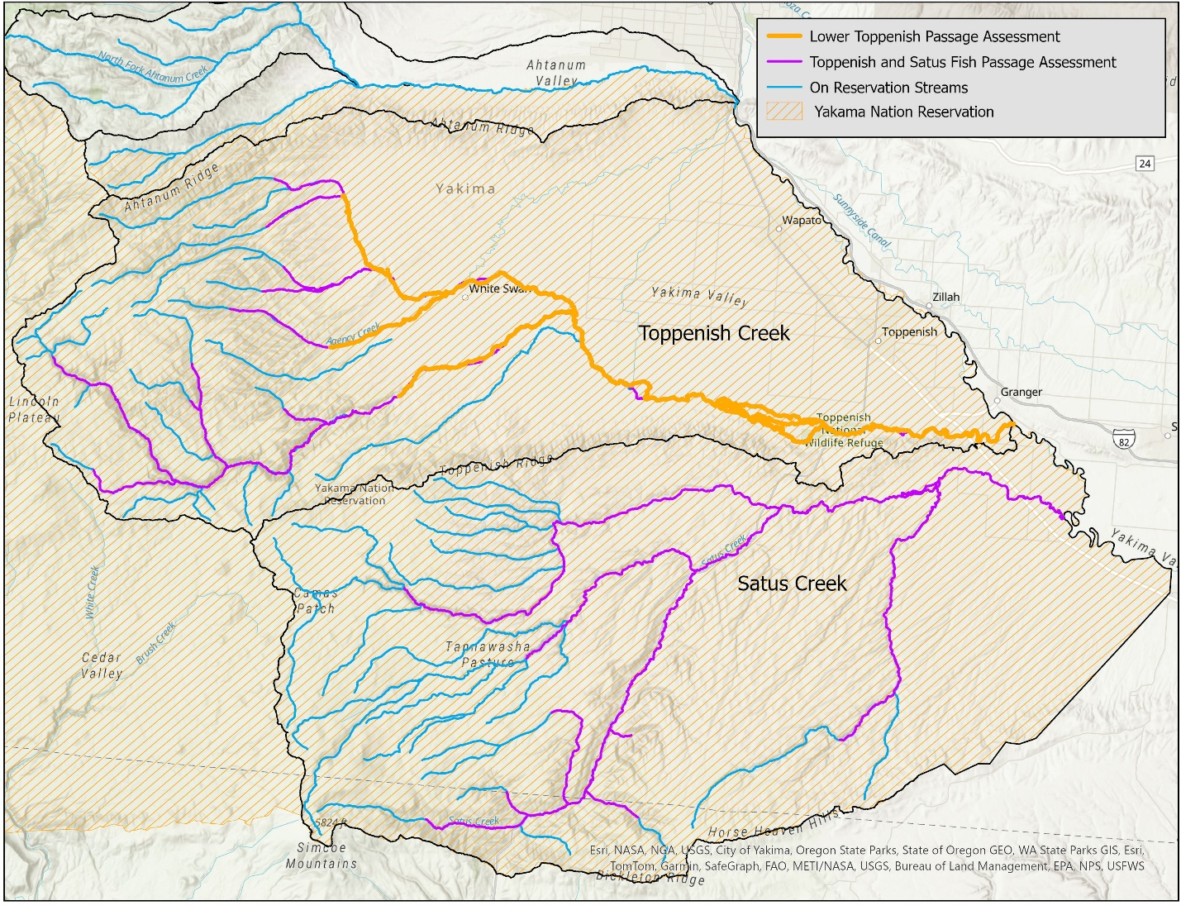

Figure . A map illustrating the scope of the passage assessment in purple.

The selected consultant will identify fish passage barriers and diversions using the standards found in the *Fish Passage Inventory, Assessment, and Prioritization Manual* provided by the Washington State Department of Fish and Wildlife. Additionally, data collected in the field will be stored in a database and visualized on an interactive web map for use by the Yakama Nation. The consultant will create a prioritization tool to rank identified fish passage barriers and diversions in order to provide Yakama Nation Fisheries with a tiered list of potential passage improvement projects. This passage assessment and prioritization will add to the ongoing project by YRWP to inventory and prioritize existing passage barriers and diversions to better streamline the project implementation process.

**Project Goals**

This assessment aims to identify and prioritize fish passage issues for adult and juvenile MCR steelhead on Toppenish and Satus Creek. This goal will be reached by achieving the following project objectives:

* + - 1. Conduct an assessment of existing fish passage barriers and diversions on 180 river miles of Toppenish and Satus Creek.
      2. Inventory identified passage barriers and diversions data in a database and web map.
      3. Create a prioritization tool using GIS software and create a prioritization of identified passage barriers and diversions.

**Scope of Work**

The proposed Scope of Work, including a cost estimate, should reflect the following components.

1. **Project Initiation and Kick off**
   1. Acquisition and Review of Available Data
      1. Yakama Nation (YN) Fisheries will provide all relevant available data.
      2. Contractor to undertake search and acquisition of relevant publicly available documents.
      3. Contractor to create and maintain a project bibliography and reference list of relevant reports, literature, and data used for the project.
      4. Contractor to create and maintain a password protected file share for the project.
   2. Kick Off Meeting (virtual)
      1. Confirm overall project approach and scope of work with respect to objectives, tasks, communication, review periods, and schedule.
      2. Discuss fieldwork plan including access points and landowner notification plan.
         1. Contractor to provide detailed maps for required site access.
      3. Access locations are subject to change based on private landowner permission (all outreach will be conducted by YN staff).
   3. Technical Memo – Project Plan Description
      1. This memo will summarize goals and objectives, approach, schedule, and field access plan. The contractor and YN will agree on a detailed implementation plan.
      2. The memo will breakdown and explain the prioritization model (similar to a basis of design report).
      3. The memo should describe how previous assessments in the project zone and other relevant available data and reports will be integrated and synthesized into the final prioritization and assessment report.
2. **Assessment Area Characterization**
   1. Fish Use and Status
      1. Contractor will work closely with YN Fisheries biologists to characterize fish use, distribution, status, and habitat conditions in Toppenish and Satus Creek.
   2. Historical Human Disturbance
      1. Explain how past land use actions play a role in current stream conditions, specifically in regards to fish passage impediments.
      2. Identify existing anthropogenic features and describe how they impact fish passage.
   3. Climate Change
      1. Describe potential changes in key watershed processes, including fish distribution, hydrology, and thermal regime due to projected climate change for the area.
   4. Technical Memo – Background Summary
      1. Report will summarize the relevant background information for the assessment area including the biophysical setting, fish use and status, historical human disturbance, and potential impacts from climate change.
3. **Field Data Collection**
   1. Stream Survey
      1. Walk survey of approximately 180 river miles of Toppenish and Satus Creek (see map) for fish passage barriers and diversions.
      2. Contractor will use WDFW standards to analyze fish passage barriers.
      3. Contractor will use WDFW standards to analyze diversions.
   2. Habitat Survey near Identified Barriers and Diversions
      1. Survey 200 meters upstream and downstream habitat of each identified barrier and diversion using USFS Level II protocols (local/sub reach).
         1. Relate habitat conditions to native salmonid and lamprey life-history requirements and stages.
         2. Entry of habitat data into standardized YN databases including a Level II habitat database and Reach Ecosystem Indicators. Both database formats will be provided to the Contractor by the YN.
4. **Development of Prioritization Tools**
   1. Fish Passage Database and Interactive Web Map
      1. Using the field data collected, the contractor will create a database of fish passage barriers and diversions.
      2. Data stored on the fish passage database will be used to create an interactive web map showing passage barriers and diversions along Toppenish and Satus Creek.
      3. Note losing reaches and potential causes (e.g., anthropogenic, natural barriers).
   2. Prioritization Model Tool
      1. Contractor will produce a prioritization model and tool for barriers using GIS software and raw field data.
         1. This tool will incorporate geographic data, ecological benefit analysis, economic considerations, and Traditional Ecological Knowledge (TEK). Examples of data that will be incorporated include the distance between barriers (geographic), and cost-to-benefit ratio (economic).
      2. The prioritization model will incorporate data collected in previous passage assessments along Toppenish and Ahtanum Creeks.
      3. The output of the tool will be a tiered list of passage improvement projects ranked from most to least impactful in terms of restoration (see Task 5 for more detail). This list will be directly influenced by the factors and data included in the prioritization model (see 4.2.a).
      4. The tool will allow for YN to upload additional passage data in the future and manipulate scoring metrics.
5. **Project Identification**
   1. Project Identification (Project ID)
      1. For each passage barrier identified and included in the tired list produced in task 4.2, the consultant will provide a project description with the following components:
         * + Photograph and description of the identified passage barrier or diversion.
           + Description of the impacts from identified passage barrier or diversion on life stages of salmonid species.
           + Description of the benefits provided by addressing passage barriers and diversions through potential restoration recommendations.
6. **Assessment Reports**
   1. DRAFT Report
      1. Compile materials and reports from Tasks 2-5; integrate and synthesize previous assessment reports and work products of current assessment, provided to YN Technical team for review.
   2. FINAL Assessment Report
      1. Integrate review comments, refine report sections, and produce final report.

**Deliverables:**

* Initial meeting with YN staff to discuss the project scope, timeline, data needs, and data availability.
* Check in meetings with YN staff to discuss progress and updates during the project.
* All reports and data collected from tasks 2-5.
* GIS prioritization tool and interactive map.
* Preliminary draft of report for YN and partner review.
* Final report, including any databases, geospatial data, bibliographies, modeling or other data developed as part of the contract.
* Any and all geospatial data developed as part of this contract delivered in ESRI geodatabase format.

**Assumptions:**

* YN will assist with site access in the assessment area.
* YN will provide relevant data to the contractor on request within a reasonable time frame, assuming it is readily available.
* YN will provide reviews and comments in a reasonably timely fashion in response to drafts of deliverables submitted by contractor.
* YN will designate a project lead who will maintain close communication and coordination with the contractor for this work.

**Proposal Evaluation and Selection Process**

**Proposal Evaluation by YN**

Bids will be evaluated and scored by YN staff on the following basis:

* Cost and value. Preference will be given to lower costs and higher value per cost, all other factors being equal.
* Timeline, with a preference for quicker delivery of the final report.
* Quality and completeness of the proposal.
* Experience and disciplinary breadth and diversity of the contractor project team.
* The quality and relevance of previous projects completed by the applicant.
* Familiarity with Toppenish and Satus Creek and Columbia Basin anadromous salmonid and lamprey biology and habitat requirements.
* References.

**Please note that Tribally owned firms are preferred.**

**Budget Table**

A completed budget table should be included within the proposal to ensure that cost-value analysis during the YN bid evaluations process is consistent amongst all proposals.

Due to the nature of the field work for this project, Task 3 from the SOW will be billed based on a rate schedule to account for time and materials spent to complete a unit (i.e., mile, barrier, diversion, etc.). The successful consultant will be given a "not-to-exceed" amount and must provide daily updates on progress to YNF staff. This is because of the uncertainty in the number of barriers present throughout the project reaches. For much of the assessment the consultant may walk several miles without encountering a barrier or diversion. However, other reaches may have several barriers and/or diversions per mile. **Proposals with incomplete budget tables will not be considered.**

Table . Budget sheet for tasks 1,2,4,5,6

|  |  |  |  |
| --- | --- | --- | --- |
| **#** | **Task Description** | **Budget Allocation** | **Estimated Timeline** |
| **1** | **Project Initiation and Kick off** |  |  |
| 1.1 | Acquisition and review of available data |  |  |
| 1.2 | Kickoff meeting (virtual) |  |  |
| 1.3 | Technical memo – project plan description |  |  |
| **2** | **Assessment Area Characterization** |  |  |
| 2.1 | Fish use and status |  |  |
| 2.2 | Historical human disturbance |  |  |
| 2.3 | Climate change |  |  |
| 2.4 | Technical memo – Background Summary |  |  |
| **4** | **Development of Prioritization Tools** |  |  |
| 4.1 | Fish passage database and interactive web map |  |  |
| 4.2 | Prioritization model |  |  |
| **5** | **Project Identification Template** |  |  |
| 5.1 | Project ID |  |  |
| **6** | **Assessment Reports** |  |  |
| 6.1 | DRAFT Assessment Report |  |  |
| 6.2 | FINAL Assessment Report |  |  |

Table . Budget sheet for task 3.

|  |  |  |  |
| --- | --- | --- | --- |
| **#** | **Task Description** | **Unit** | **Price** |
| **3.1** | **Stream Survey** |  |  |
| a | Passage barrier survey (walking rate if no barriers identified) | per mile |  |
| b | Barrier Identification | per barrier |  |
| c | Diversion Identification | per diversion |  |
| **3.2** | **Habitat Survey (near Barriers/Diversions)** |  |  |
| a | Habitat survey 200 meters upstream and downstream of identified barriers and diversions. | per barrier or diversion |  |

Table . Budget sheet for direct expenses. Please include total project cost including all tasks and direct expenses.

|  |  |
| --- | --- |
| **Direct Expenses Allocation** |  |
| Office Expenses |  |
| Field Supplies |  |
| Mileage |  |
| Lodging | GSA Rate |
| Per Diem | GSA Rate |
|  |  |
| Direct Expenses Subtotal |  |
| Total Project Cost (all tasks and direct expenses) |  |

CONSULTANT SERVICES AGREEMENT EXAMPLE

This consultant services agreement is between the CONFEDERATED TRIBES AND BANDS OF THE YAKAMA NATION, a sovereign native nation with its governmental headquarters located at P.O. Box 151 / 401 Fort Road, Toppenish, WA 98948 on the Yakama Reservation (“**Yakama Nation**”), and [CONSULTANT’S NAME], Tax ID Number _______________, with its primary place of business located at [address] (“**Consultant**”).

The Yakama Nation wants to obtain technical assistance to accomplish the project, task, study, or other work described in Exhibit A (Scope of Work) to this agreement.

Consultant states that it has the necessary technical expertise, skill, and capability to complete this work for the Yakama Nation.

The parties therefore agree as follows:

# STATEMENT OF SERVICES

## Work & Standard of Performance. Consultant shall perform the work described in Exhibit A (Scope of Work) to this agreement (the “Work”). Consultant shall, at its sole expense, provide all labor, services, and equipment necessary to complete the Work timely and to the Yakama Nation’s satisfaction, except as expressly provided otherwise in this agreement. Consultant’s performance shall comply with applicable tribal, federal, state, and local law and policy, and be consistent with generally accepted professional best practices, both of which Consultant states it has knowledge of.

## Term. This agreement will be effective on the date when both parties have signed it, and will terminate as set forth below, unless terminated earlier in accordance with Article 9 of this agreement (if neither option is selected, Option B shall be the default):

## *Option A:* On March 31, 2026

## *Option B:* Upon Consultant’s satisfactory performance of the Work.

## Prior Performance. If the Consultant has performed any Work prior to the effective date of this agreement, then this agreement will govern such prior performance. Except that the Consultant’s invoicing obligations, and the Yakama Nation’s associated payment obligations, as set forth in Exhibit C (Payment Terms), will not arise until after the effective date of this agreement.

## Key Personnel. If any of Consultant’s employees or agents are specifically identified in Exhibit A (Scope of Work) as the employee(s) or agent(s) expected to perform the Work, they will be considered Consultant’s “Key Personnel” for purposes of this agreement. Consultant shall ensure that Key Personnel continue to be assigned to the Work until its completion, unless Consultant obtains the Yakama Nation Project Manager’s written consent to a staff substitution.

# COMPENSATION

## Maximum Compensation. The maximum total compensation approved by the Yakama Nation and payable to Consultant for Work under this agreement is $________________. The Yakama Nation shall not pay Consultant more than this maximum amount for the Work. Consultant acknowledges that this maximum amount (a) is sufficient to perform the Work consistent with the terms and conditions of this agreement and (b) includes all eligible expenses associated with Consultant’s performance of the Work.

## Payment. The Yakama Nation shall pay Consultant according to the invoicing and payment terms described in Exhibit B (Budget) and Exhibit C (Payment Terms) to this agreement.

## Expenses. The Yakama Nation shall only compensate Consultant for eligible expenses directly associated with the performance of the Work. Consultant acknowledges that “eligible expenses” means reasonable, allocable, and allowable expenses that are incurred by Consultant in performance of the Work with the prior written approval of the Yakama Nation, for which the Consultant provides a reasonably detailed receipt or other proper proof. The Yakama Nation shall pay eligible expenses, including any authorized travel expenses, consistent with applicable tribal and/or federal law and policy.

## Federal, State, or Privately Granted Funds. The Work is being funded utilizing the following type(s) of funds:

## Yakama Nation:

## Federal: National Oceanic and Atmospheric Administration

## State:

## Other:

### *Compliance.* Consultant acknowledges that federal, state, or grant funds utilized to compensate Consultant may be subject to certain laws, regulations, requirements and restrictions, which may include, but are not limited to, 2 C.F.R. Part 200. Consultant shall utilize funds in accordance with applicable funding requirements and restrictions, and shall reimburse the Yakama Nation for any expenses that are paid by the Yakama Nation but subsequently disallowed by the federal or state agency or other grantor.

### *Availability of Funds.* Consultant acknowledges that where the Work is funded by federal, state, or other external sources, Yakama Nation’s payment obligations to Consultant for Work under this Agreement are entirely dependent and conditioned upon Yakama Nation receiving the funds from such agency or agencies.

# PROJECT MANAGEMENT

## Project Managers. Each party will designate an internal project manager to facilitate the completion of the Work. Being designated as a party’s project manager does *not* endow the representative with any legal authority to bind that party. Either party may change their project manager by giving notice to the other party.

### The Yakama Nation’s Project Manager is Rebecca Mitre. She may be reached at (509)506-5026 , or [mitr@yakamafish-nsn.gov](mailto:mitr@yakamafish-nsn.gov) .

### The Consultant’s Project Manager is [Name]. S/he may be reached at [Phone], or [email].

# LEGAL NOTICE

## Valid Notice. For a notice under this agreement to be valid, it must be in writing, properly addressed to the party’s current legal contact, and delivered (a) by a national transportation company with all fees prepaid and receipt signature required, or (b) by USPS certified mail, return receipt requested, postage prepaid. Notice will be effective upon the date of receipt. Either party may change its designated address or recipient for legal notice by giving the other party reasonable notice of such change.

## Notice to the Yakama Nation. Notice to the Yakama Nation must be sent to the Tribal Council Chairman at P.O. Box 151 / 401 Fort Road, Toppenish, WA 98948, with courtesy copies to the Yakama Nation’s Project Manager electronically at their email address listed above in section 3.01(a), and to the Yakama Nation Office of Legal Counsel at P.O. Box 150 / 401 Fort Road, Toppenish, WA 98948.

## Notice to Consultant. Notice to Consultant must be sent to _____________________ at __________________________________________________________________________________________________________________________________________________________________________

# RECORDS, ACCOUNTING & AUDITS

## Recordkeeping. Consultant shall maintain auditable records during the term of this Agreement and for a period of at least three (3) years following the termination of this Agreement. Consultant shall comply with the Audit Act of 1984, P.L. 98-502 (31 U.S.C. § 7501 et. seq.), as amended, and the Office of Management and Budget’s Uniform Guidance requirements set forth at, 2 C.F.R. Part 200, Subpart F, as amended, in maintaining its records.

## Accounting. Consultant shall adhere to a systematic accounting method in performing the Work to ensure timely and appropriate resolution of audit findings and recommendations, and compliance with the Office of Management and Budget’s Uniform Guidance requirements set forth at, 2 C.F.R. Part 200, Subpart F, as amended.

## Audits. Except as prohibited by law, the Yakama Nation, the United States (if applicable), and any grantor agency (if applicable), and/or their duly authorized representative(s), may audit, examine, request, or make copies of Consultant’s records that concern or are relevant to the subject matter of this agreement or to Consultant’s performance of its obligations under this agreement. Consultant shall provide such authorized auditors with timely access to its records.

## Access to Yakama Nation Records, Personnel & Facilities. Except as prohibited by law, the Yakama Nation shall provide Consultant with reasonable access to its personnel, facilities, and records necessary for Consultant’s performance of this agreement.

## Confidential Information. If the Yakama Nation provides Consultant with documents or information typically maintained as confidential by the Yakama Nation (“Confidential Information”), Consultant shall make all reasonable efforts, and take all reasonable precautions, to prevent the disclosure of that Confidential Information to non-parties, except as may be required by law or court order. Consultant shall not use Confidential Information for any purpose except the performance of this agreement.

## Continuing Obligation. Consultant’s obligations under Article 5 of this agreement are intended to survive the termination of this agreement.

# WORK PRODUCT

## Definition*.* “Work Product” includes, but is not limited to, all papers, reports, information, drawings, internal memoranda, files, proposals, papers, copyrights, patents, photographs, data, and all written or graphic material, or any other material or property, whether stored electronically or in hard copy, in any format including native formats, and however produced, prepared, collected, generated, or created by the Consultant in connection with this agreement.

## Ownership. Consultant acknowledges that all Work Product it produces pursuant to this agreement will be works for hire, which the Yakama Nation will own, and which Consultant will not retain any interest in or rights to. Consultant shall give all its Work Product to the Yakama Nation promptly upon the termination of this agreement or upon request in a format acceptable to the Yakama Nation.

# RISK MANAGEMENT

## Insurance Requirement. Consultant shall be required to purchase and maintain insurance during the term of this agreement, as set forth in Section 7.02 below: YES NO . (If neither box is checked, insurance is required.)

## Insurance Coverage. If insurance is required under Section 7.01, Consultant shall, at its own expense, maintain the following minimum insurance coverage during the term of this agreement and for a period of three years following the completion of the Work:

### Either Commercial General Liability Insurance OR Professional Liability Insurance, including errors and omissions insurance, in the amount of at least one million dollars ($1,000,000) per occurrence and two million dollars ($2,000,000) aggregate.

### If the performance of the Work requires Consultant to use one or more automobiles, Commercial Automobile Insurance coverage for all vehicles used in performance of the Work in an amount equal to the greater of either (i) one million dollars ($1,000,000), or (ii) any other amount specified by applicable law.

### Any other insurance coverage required by applicable law, which may include (but may not be limited to) worker’s compensation insurance or disability benefits insurance.

## Additional Insured. Consultant shall name the Yakama Nation as an additional insured on its applicable insurance policies, provide the Yakama Nation with certificates of insurance, and at the Yakama Nation’s request, provide Yakama Nation with copies of the relevant policies. The additional insured coverage provided by Consultant to Yakama Nation shall be on a primary and noncontributory basis.

## No Subrogation. Consultant hereby waives for insurance purposes all subrogation rights it may have against the Yakama Nation and any of the Yakama Nation’s officers, agents, employees, governmental entities, contractors, or subcontractors.

## Indemnification. Consultant shall indemnify, hold harmless, and (at the Yakama Nation’s discretion, and with counsel acceptable to the Yakama Nation) defend the Yakama Nation and its officers, agents, employees, and assigns (each and all considered the “Yakama Nation” for purposes of this Section) against any claim, demand, judgment, loss, cost, damage, expense or other liability whatsoever, including legal fees and expenses, which are incurred by or claimed against the Yakama Nation and arise, either directly or indirectly, from any action, omission, error or breach of contract by Consultant or its officers, agents, employees, or subcontractors. The requirements of this Section 7.05 are intended to survive the termination of this agreement.

## Injunctive Relief. Consultant acknowledges that its breach or threatened breach of Article 5 (Records, Accounting, Audits) or Article 6 (Work Product) of this agreement would cause irreparable injury to the Yakama Nation, which could not be completely compensated by money damages, and that injunctive relief to enforce Articles 5 or 6 of this agreement would be proper.

# DISPUTE RESOLUTION

## Negotiation. If the parties disagree about the performance, interpretation, or enforcement of this agreement, they shall first attempt to resolve their disagreement informally through (a) dialogue between their project managers, and then (b) face-to-face negotiations between their leaders, which must be held in Toppenish, WA. If the parties cannot resolve their disagreement after taking these steps, it will be deemed a ‘dispute’.

## Dispute Resolution. The aggrieved Party shall submit the dispute, in writing, to the Chairman of the Yakama Nation Tribal Council. A copy of the aggrieved party's submission shall be served upon the other party in accordance with the notice provisions of this Agreement. The Chairman shall promptly convene a meeting of the Parties, which shall be held in Toppenish, Washington, to resolve the matter. The decision of the Chairman shall be final and binding upon both Parties. In the event that the Chairman has a conflict of interest that would prevent her/him from hearing the dispute, s/he may, at her/his sole discretion, either decline to hear the dispute, or appoint an alternate Tribal Leader or Elder to serve in his/her place.

# TERMINATION

## For Convenience. Either party may terminate this agreement by giving to the other party at least 90 days prior written notice. The notice must specify the effective date of termination.

## For Breach. Either party may immediately terminate this agreement by written notice following a material breach by the other party. The parties acknowledge that the terms of Article 5 (Records, Accounting & Audits), Article 7 (Risk Management), and Section 1.04 (Key Personnel) are material terms. Consultant acknowledges that time is of the essence for performance of the Work.

## By Tribal Council Executive Committee. The Yakama Nation Tribal Council Executive Committee may immediately terminate this agreement upon written notice to Consultant.

## Effect. Termination of this agreement will not relieve either party of any liabilities or obligations that arise under this agreement before the agreement is terminated. Termination will not limit the Yakama Nation’s rights or remedies at law or equity, including, but not limited to, the right to contract with other qualified persons to complete the Work.

# GENERAL TERMS

## Independent Contractor. Consultant acknowledges that it is an independent contractor and not an agent or employee of the Yakama Nation for purposes of this agreement. The parties state that they are not engaged in a joint venture or partnership. Neither party may speak for or bind the other.

## Conflicts. During the term of this agreement, Consultant shall not accept work from any non-party, which would create a real or apparent conflict of interest with Consultant’s performance of the Work for the Yakama Nation.

## Subcontractors. Consultant shall not hire a subcontractor to perform any portion of the Work for this Agreement, except as expressly authorized in writing by the Yakama Nation. Where the Yakama Nation has authorized Consultant’s hiring of a subcontractor, Consultant shall require the subcontractor to comply with all relevant terms and conditions of this agreement in performing their portion of the Work. Any unauthorized attempt by Consultant to subcontract the Work will be null and void, and Consultant shall be responsible for all expenses, fees, and costs associated with the unauthorized subcontract(s).

## Fair Employment Practices. Consultant shall not discriminate against any employee or applicant for employment because of handicap, race, age, religion, sex, gender, or sexual orientation. Consultant shall take affirmative steps to ensure that applicants and employees are treated fairly during hiring and employment. This provision is not intended to prevent Consultant from implementing a lawful Indian preference employment policy.

## Indian Preference Employment. When Consultant performs Work within the boundaries of the Yakama Reservation, or on Yakama trust property outside the boundaries of the Yakama Reservation, Consultant acknowledges that it is subject to and shall comply with applicable Indian preference employment laws of the Yakama Nation, including its Tribal Employment Rights Ordinance (Yakama Revised Law & Order Code, Title 71, as amended) (“TERO”). Consultant further acknowledges that under Section 703(i) of the 1964 Civil Rights Act, it may implement an Indian Preference hiring policy for all work performed near (within reasonable commuting distance from) the Yakama Reservation. Consultant hereby adopts the TERO and its associated policies as its Indian preference hiring policy for Work it performs near the Yakama Reservation, and shall publicize the same.

## Permits and Approvals; Taxes and Fees. The Consultant shall, at its expense, obtain any and all permits, approvals, or authorizations from local, state, federal or tribal authorities necessary or required for the completion of the Work. Unless the parties have expressly agreed otherwise in this agreement, Consultant shall pay any taxes or fees applicable to or associated with its completion of the Work.

## Force Majeure. The parties’ obligations under this agreement are subject to force majeure. If acts of God, severe weather conditions, fire, or unforeseen catastrophic events caused by nonparties which are beyond the control of the parties, prevent the parties from performance, such non-performance must not be considered a breach of this agreement.

## Entire Agreement. This agreement constitutes the entire understanding between the parties with respect to the subject of this agreement, and supersedes all prior or contemporaneous agreements, whether written or oral, between the parties. The parties acknowledge that they each participated in negotiating this agreement, and that they have read, understood, and approved its terms. Headings are provided in this agreement for convenience, and are not intended to affect the meaning of the provisions to which they are affixed.

## Exhibits Incorporated by Reference. This agreement includes any terms or documents incorporated by reference, as well as those exhibits listed below. If the terms of an exhibit or incorporated document conflict with the terms of the body of this agreement, the terms in the body of this agreement must prevail.

#### Exhibit A – Scope of Work

#### Exhibit B – Budget

#### Exhibit C – Payment Terms

(v) [n/a]

## Change Orders. Change orders must be in writing and authorized by an appropriate representative of the Yakama Nation as follows:

### *Material Changes.* Any material changes to this agreement or the Work to be performed must be authorized in writing and signed by the Yakama Nation Tribal Council Chair as modifications or addendums to this agreement. Material changes are (i) any changes which require an increase in the maximum ‘not to exceed’ contract amount set forth in Section 2.01 of this agreement, or (ii) any changes to *what* Work is to be performed.

### *Immaterial Changes.* The Yakama Nation’s Project Manager may authorize immaterial changes in writing. Immaterial changes are those that concern *how* the Work will be accomplished, but do *not* change the scope of what Work will be performed, or the overall contract payment amount.

## Amendments; Waiver. The parties may amend this agreement by a written instrument signed by the authorized representatives of both parties. No waiver of a right or obligation under this agreement will be effective unless it is in writing and signed by an authorized representative of the party granting the waiver. A waiver granted on one occasion will not operate as a waiver on other occasions.

## Execution. If the parties sign this agreement in several counterparts, each will be deemed an original, but all counterparts together will constitute one instrument. The parties may sign and deliver this agreement (and any ancillary documents) to each other electronically, and the receiving party may rely on the electronic document as if it was a hard-copy original.

## Choice of Law and Venue. Yakama law governs the validity and interpretation of this agreement, and any adversarial proceedings brought by one party against the other party arising out of this agreement. Any court action filed to enforce or interpret this agreement must be in the Yakama Tribal Courts. Consultant acknowledges that this agreement will be considered to have been executed at the Yakama Nation governmental headquarters in Toppenish, WA, and that this agreement establishes a consensual business relationship between the parties for purposes of Yakama Tribal Court jurisdiction. Consultant shall not raise any personal jurisdiction objections to Tribal Court jurisdiction.

## Severability. If any term of this agreement is found to be illegal, otherwise invalid, or incapable of being enforced, such term shall be excluded to the extent of such invalidity or unenforceability. All other terms shall remain in full force and effect; and, to the extent permitted and possible, the invalid or unenforceable term shall be deemed replaced by a term that is valid and enforceable that comes closest to expressing the parties’ original intention.

## Sovereign Immunity. In entering into this agreement, the Yakama Nation is not waiving its sovereign immunity from suit, and is not waiving, altering, or otherwise diminishing its rights, privileges, remedies, or services guaranteed by the U.S. Treaty with the Yakamas of June 9, 1855.

## Special Terms & Conditions. In addition to the forgoing terms and conditions, the following requirements will apply to this Agreement:

**[Signature pages follow.]**

**Each party is signing this agreement on the date stated opposite that party’s signature:**

**THE CONFEDERATED TRIBES AND BANDS OF THE YAKAMA NATION:**

By: Gerald Lewis Date

Title: Tribal Council Chairman

**[CONSULTANT]:**

EIN #:

By: Date

Title:

EXHIBIT A – SCOPE OF WORK

1. **Background:**

Toppenish and Satus Creek are critical habitat for Middle-Columbia River (MCR) steelhead within the Yakima Basin. These two watersheds support up to 40% of the annual adult steelhead run within the basin. However, a steady decline in the steelhead population on these tributaries has led to restrictions on traditional fish harvests. Throughout the years, several reach based assessments have been done along Toppenish and Satus Creeks. However, a large-scale, comprehensive, and systematic passage assessment has not been conducted on these tributaries.

**Scope:**

The consultant will be tasked with collecting data in the field regarding fish passage barriers and diversions using the standards found in the *Fish Passage Inventory, Assessment, and Prioritization Manual* provided by the Washington State Department of Fish and Wildlife. The consultant will use the data collected in the field and compile it into database for use by the Yakama Nation. In addition to a database, the consultant will create a prioritization model to rank the identified fish passage barriers and diversions in order to provide Yakama Nation Fisheries with a tiered list of potential passage improvement projects.

1. **Requirements:**

**Tasks**

1. Project Initiation and Kick off
   1. Acquisition and Review of Available Data
      1. Yakama Nation (YN) Fisheries will provide all relevant available data.
      2. Contractor to undertake search and acquisition of relevant publicly available documents.
      3. Contractor to create and maintain a project bibliography and reference list of relevant reports, literature, and data used for the project.
      4. Contractor to create and maintain a password protected file share for the project.
   2. Kick Off Meeting (virtual)
      1. Confirm overall project approach and scope of work with respect to objectives, tasks, communication, review periods, and schedule.
      2. Discuss fieldwork plan including access points and landowner notification plan.
         1. Contractor to provide detailed maps for required site access.
      3. Access locations are subject to change based on private landowner permission (all outreach will be conducted by YN staff).
   3. Technical Memo – Project Plan Description
      1. This memo will summarize goals and objectives, approach, schedule, and field access plan. The contractor and YN will agree on a detailed implementation plan.
      2. The memo will breakdown and explain the prioritization model (similar to a basis of design report).
      3. The memo should describe how previous assessments in the project zone and other relevant available data and reports will be integrated and synthesized into the final prioritization and assessment report.
2. Assessment Area Characterization
   1. Fish Use and Status
      1. Contractor will work closely with YN Fisheries biologists to characterize fish use, distribution, status, and habitat conditions in Toppenish and Satus Creek.
   2. Historical Human Disturbance
      1. Explain how past land use actions play a role in current stream conditions, specifically in regards to fish passage impediments.
      2. Identify existing anthropogenic features and describe how they impact fish passage.
   3. Climate Change
      1. Describe potential changes in key watershed processes, including fish distribution, hydrology, and thermal regime due to projected climate change for the area.
   4. Technical Memo – Background Summary
      1. Report will summarize the relevant background information for the assessment area including the biophysical setting, fish use and status, historical human disturbance, and potential impacts from climate change.
3. Field Data Collection
   1. Stream Survey
      1. Walk survey of approximately 180 river miles of Toppenish and Satus Creek (see map) for fish passage barriers and diversions.
      2. Contractor will use WDFW standards to analyze fish passage barriers.
      3. Contractor will use WDFW standards to analyze diversions.
   2. Habitat Survey near Identified Barriers and Diversions
      1. Survey 200 meters upstream and downstream habitat of each identified barrier and diversion using USFS Level II protocols (local/sub reach).
         1. Relate habitat conditions to native salmonid and lamprey life-history requirements and stages.
         2. Entry of habitat data into standardized YN databases including a Level II habitat database and Reach Ecosystem Indicators. Both database formats will be provided to the Contractor by the YN.
4. Development of Prioritization Tools
   1. Fish Passage Database and Interactive Web Map
      1. Using the field data collected, the contractor will create a database of fish passage barriers and diversions.
      2. Data stored on the fish passage database will be used to create an interactive web map showing passage barriers and diversions along Toppenish and Satus Creek.
      3. Note losing reaches and potential causes (e.g., anthropogenic, natural barriers).
   2. Prioritization Model Tool
      1. Contractor will produce a prioritization model and tool for barriers using GIS software and raw field data.
         1. This tool will incorporate geographic data, ecological benefit analysis, economic considerations, and Traditional Ecological Knowledge (TEK). Examples of data that will be incorporated include the distance between barriers (geographic), and cost-to-benefit ratio (economic).
      2. The prioritization model will incorporate data collected in previous passage assessments along Toppenish and Ahtanum Creeks.
      3. The output of the tool will be a tiered list of passage improvement projects ranked from most to least impactful in terms of restoration (see Task 5 for more detail). This list will be directly influenced by the factors and data included in the prioritization model (see 4.2.a).
      4. The tool will allow for YN to upload additional passage data in the future and manipulate scoring metrics.
5. Project Identification
   1. Project Identification (Project ID)
      1. For each passage barrier identified and included in the tired list produced in task 4.2, the consultant will provide a project description with the following components:
         1. Photograph and description of the identified passage barrier or diversion.
         2. Description of the impacts from identified passage barrier or diversion on life stages of salmonid species.
         3. Description of the benefits provided by addressing passage barriers and diversions through potential restoration recommendations.
6. Assessment Reports
   1. DRAFT Report
      1. Compile materials and reports from Tasks 2-5; integrate and synthesize previous assessment reports and work products of current assessment, provided to YN Technical team for review.
   2. FINAL Assessment Report
      1. Integrate review comments, refine report sections, and produce final report.
7. **Applicable Documents:**

* Fish Passage Inventory, Assessment, and Prioritization Manual

1. **Deliverables:**

* Initial meeting with YN staff to discuss the project scope, timeline, data needs, and data availability.
* Check in meetings with YN staff to discuss progress and updates during the project.
* All reports and data collected from tasks 2-5.
* GIS prioritization tool and interactive map.
* Preliminary draft of report for YN and partner review.
* Final report, including any databases, geospatial data, bibliographies, modeling or other data developed as part of the contract.
* Any and all geospatial data developed as part of this contract delivered in ESRI geodatabase format.

EXHIBIT B – BUDGET

**1. Project Budget:**

**2. Applicable Rate Schedule.** Consultant shall invoice, and the Yakama Nation shall pay, according to the following rate schedule:      .

EXHIBIT C – PAYMENT TERMS

**1. Schedule.** The Consultant shall invoice for work performed in accordance with the following schedule [if no schedule is selected, invoicing shall occur per Option A – Monthly Time & Materials:

*A. Monthly Time & Materials:*The Consultant shall invoice monthly on a time and materials basis for actual Work completed during the invoice period. Unless the parties agree in writing to different terms, invoice periods shall begin on the first day of each month and end on the last day of each month.

*B. Progress:*The Consultant shall invoice following the completion of each major Work task identified in Exhibit A (Scope of Work). A Work task will not be considered complete until it has been reviewed and accepted by Yakama Nation’s Project Manager.

*C. Alternative Schedule:*The Consultant shall invoice as follows: _____________________.

**2. Invoicing Requirements.** Invoices must include appropriate supporting documentation, which may include, but is not limited to, detailed expense receipts, and a brief summary of activities associated with the Work performed by Consultant. Consultant shall submit invoices to the Yakama Nation’s designated Project Manager within 15 days after the end of the invoice period in which the Work was performed and/or expenses were incurred. Consultant hereby waives the right to receive full payment on invoices submitted more than 60 days following the end of the invoice period. (The ‘end’ of the invoice period for progress payments will be considered the last day of the calendar month in which the Work task was completed.)

If a question or concern arises regarding an invoice, Yakama Nation shall promptly notify Consultant of the question or concern. Within 15 business days following such notification, Consultant shall sufficiently explain or correct the issue, or Consultant will be deemed to have waived their right to demand payment for the associated Work or expense.

**3. Payment.** Subject to the terms of this Agreement, the Yakama Nation shall pay all approved invoices within 60 days following the date of invoice.

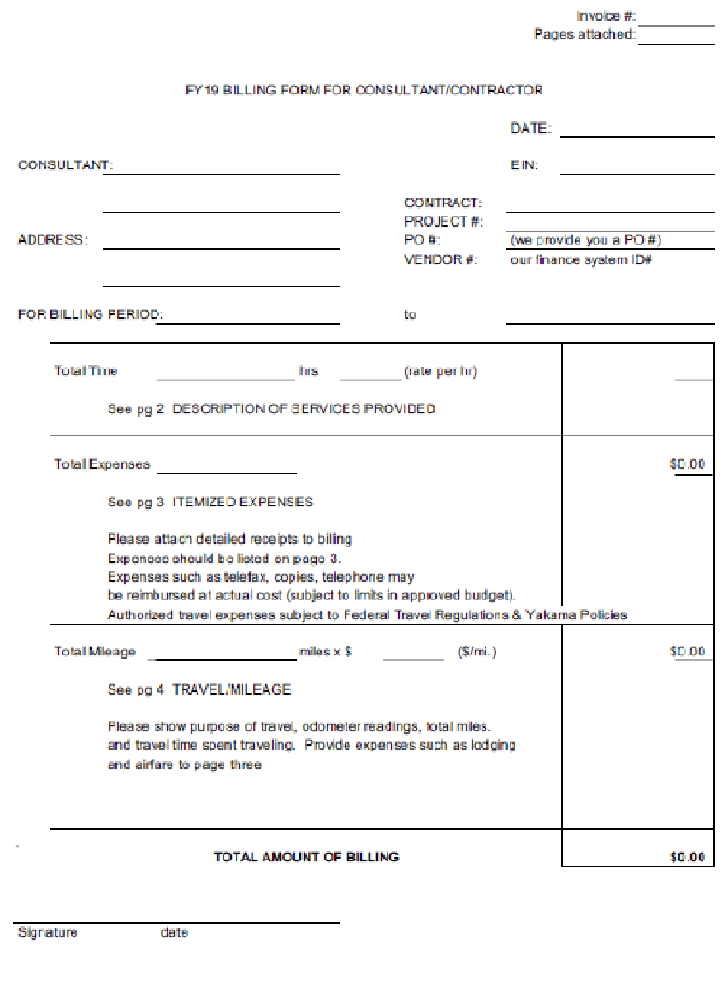

FY 24

