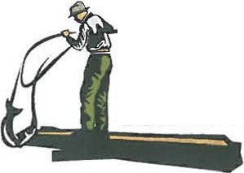Yakama Nation Fisheries

Columbia River
Honor. Protect. Restore.

OFFICE
P 0 Bu 151
401 Fort Ro.;d

PHONE

FAX
:sos)865-J2So

EMAIL

WEB
MEMORANDUM

Date: January 16, 2018

To: Tribal Fishers

From Fish and Wildlife Committee Gerald Lewis, Chairman

CC: Fisheries Harvest Coordinator
Roger Dick, Jr.,

Subject: Fishers Meeting- February 5, 2018

The Fish and Wildlife Committee directed Fisheries Staff to schedule a fishers meeting for Monday, February 5, 2018, from 10 a.m. to 4 p.m. at the CHC Heritage Theatre, Toppenish, WA. Lunch will be provided.

Topics for discussion include:

1. Winter Season 2018
a. Season Regulations
b. Sturgeon Guidelines and Catch
i. The Dalles Pool Guideline Adjustment
ii. Winter Gillnet Season Structure
c. Smelt Information

2. Spring Season 2018
a. Forecasts and Catch Guidelines
b. Spring Season 2017 Review
c. Preliminary Fisheries Outlook

3. Other Topics
a. Drift Net Length
b. Marine Mammal Regulations
c. In Lieu/ Treaty TFAS Site
d. Enforcement
e. Salmon Marketing
f. Other???

