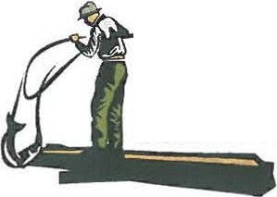
Yakama Nation Fisheries

Columbia River
Honor. Protect. Restore.

OFFICE
PO Box 151
401 Fort Road
Toppenish, WA 98648

PHONE

FAX
(509)865-6850

EMAIL
dicr@yakamafish-nsn.gov

WEB

MEMORANDUM

Date: March 12, 2018

To: Tribal Fishers

From Fish and Wildlife Committee Gerald Lewis, Chairman

CC: Fisheries Harvest Coordinator
Roger Dick, Jr.,

Subject: Fishers Meeting- March 19, 2018

The Fish and Wildlife Committee directed Fisheries Staff to schedule a fishers meeting for Monday, March 19, 2018, from 10 a.m. to 4 p.m. at the Hood River Inn, Hood River, OR. Lunch will be provided.

Topics for discussion include:

1. Spring Season 2018
a. Forecasts and Catch Guidelines
b. Fisheries Outlook

2. Summer Season 2018
a. Forecasts and Catch Guidelines
b. Fisheries Outlook

3. Other Topics
a. In Lieu/ Treaty TFAS 11:00am
b. Ocean Harvest 11:30am
c. Enforcement
d. Salmon Marketing
e. Other???

