YAKAMA NATION FISHERIES ANNOUCEMENT
September 12, 2018

The Yakama Nation Fish and Wildlife Committee has decided to postpone deciding next fall season opening.

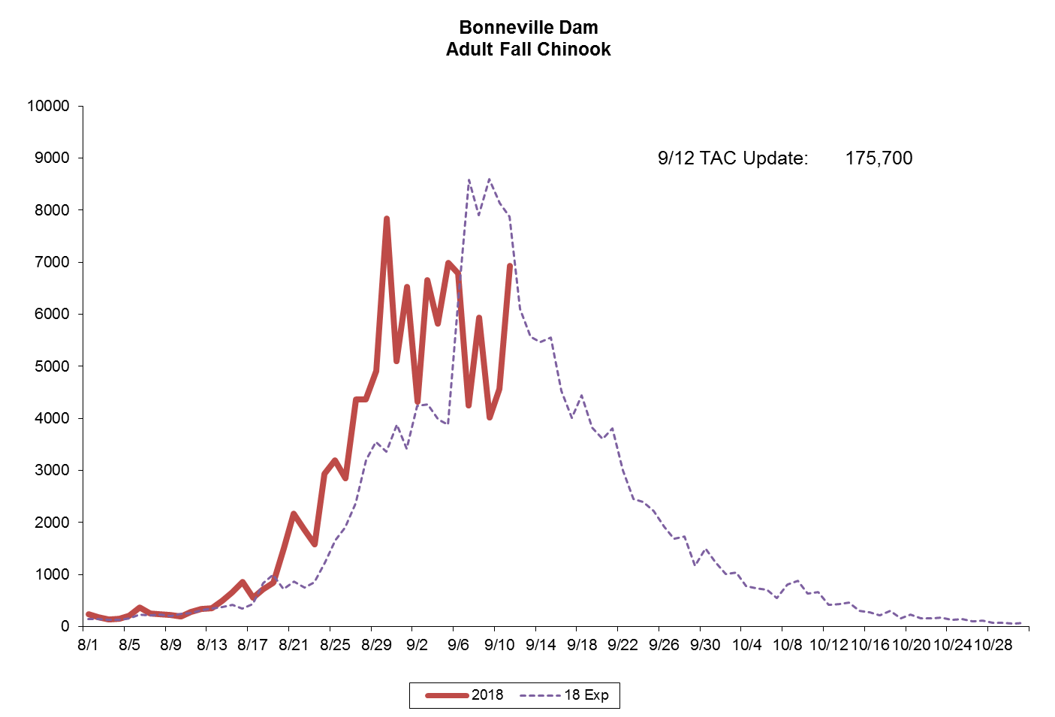
- Fall Chinook has been lower than expected and Upriver Bright Fall Chinook (URB) have been downgraded to 138,600 at the mouth of the Columbia River.
- There is concern Fall Chinook may drop lower as daily passage at Bonneville Dam continues to lag.
- The States of Oregon and Washington have taken Action to close all State Fall Chinook Fisheries.
- The tribes met and decided to wait until Tuesday, September 18, 2018 to decide on the Fall Season.
- If the URB run size drops even lower, there is risk the Treaty Fishery will exceed the URB Harvest Rate Limit and all Treaty Salmon Fisheries on the Columbia River would need to close, including the Platform/hook and line.
- The US v OR Technical Advisory Committee will continue meeting weekly on Mondays to update run sizes and catches.
- The Tribes will also continue meeting weekly to consider further fishing opportunity.

For further information please contact Roger Dick, Jr. at the Fisheries Office at 509/865-5121 ext. 6341 or Cell 509/945-0771.

